Goleta Point Faculty Project

Biological Environmental Impact Report

March 2021

Biological Environmental Impact Report

Goleta Point Faculty
Project

Prepared for:
David Stone

Prepared by:
Kay Carter

March 2020
Table of Contents

1.0 INTRODUCTION………………………………………………………………………………………………………………………3
2.0 PROJECT DESCRIPTION……………………………………………………………………………………………………………4
3.0 ENVIRONMENTAL SETTING…………………………………………………………………………………………………..12
4.0 IMPACTS ANALYSIS………………………………………………………………………………………………………….……21
5.0 CUMULATIVE IMPACTS…………………………………………………………………………………………………………30
6.0 PROJECT ALTERNATIVES…………………………………………………………………………………….…………………41
PUBLIC COMMENTS………………………………………………………………………………………….……………………….54
DEIR EDITS IN RESPONS TO COMMENTS………………………………………………………….………………………..55
REFERENCES……………………………………………………….……………………………………………………….…….………56

1.0 Introduction

This Document is a Final Environmental Impact Report EIR for the Goleta Point Faculty project. The proposed project involves the development of a three-story multiuse structure with 23 units of residential faculty housing and 12 classrooms.

This section discusses the environmental review process required under the California Environmental Quality Act (CEQA).

1.1 Purpose of CEQA
In accordance with CEQA guidelines 15121, The purpose of an EIR is to serve as an informational document that:
“will inform public agency decision‐makers and the public generally of the significant environmental effects of a project, identify possible ways to minimize the significant effects, and describe reasonable alternatives to the project.”
1.2 Environmental review Process
The major steps of the environmental review process, as required by CEQA, are outlined below in sequel order.
- Notice of Preparation (NOP). When an EIR if required, the Lead Agency (UCSB Office of Planning and Research) files a NOP, notifying the responsible agency that the lead agency plans on preparing an EIR report
- Draft Environmental Impact Report Prepared. The Draft EIR must contain all necessary components of an EIR.
- Notice of Completion. A Notice of Completion is filed by the lead agency with the state clearinghouse, and public notice of availability must be made.
- Final EIR. A final EIR must contain the DEIR, copies of comments received with a list of who commented, and responses to those comments.
- Lead Agency Project Decision. The lead agency may disapprove of a project because of the significant impact, require a change or approve a project despite significant impact if it qualifies for an n overriding consideration.
- Finding/statement of overriding consideration. An overriding consideration must be prepared for a project that was approved for it social, economic, or other reason despite having a significant impact.
- Mitigation Monitoring and Reporting Program. When an EIR is adopted, it must adopt a reporting. Monitoring program for mitigation measures that were adopted
- Notice of Determination. The Lead agency files a Notice of Determination after choosing to approve a project.
2.0 PROJECT DESCRIPTION
2.0 Project description will provide a very general description of major components 2.1 Project Objectives, 2.2 Project Location, 2.3 Surrounding Land Uses, 2.4 Project Construction, and 2.5 Project operations. The Project Objections section covers the basic goals of the project and its purpose. Section 2.2 covers where the project is located and surrounding land use within the vicinity of the project. Section 2.4 covers the project’s construction process, and the last section covers the operational use of the proposed multi-use structure.

2.1 Project Objectives
The Goleta Point Faculty Housing Project addresses the need for additional Faculty housing and educational classroom space for the University of California Santa Barbara that has long been acknowledged.
The proposed project will consist of a 40, acres, 3 story that is 36-feet high with approximately 12 classrooms and parking on the first floor. The 2nd and 3rd stories will consist of 23 residential units with 1, 2, or 3 bedrooms. A perimeter fence will be constructed around the premise.
The development of the structure will allow for UCSB to achieve the following objectives:

- Construct a 44,000-acre mixed-use building with UCSB faculty residential units and classrooms
- Add 23 new faculty residential units
- lessen the commute between work and home
- Support recruitment and retention of faculty and staff
- meet long-term demand for affordable faculty
- provide attractive location to encourage new faculty
- Add 12 new classrooms that are
  - Allow for students and faculty to get to additional classes within 10 minutes allotted time between classes
  - to address the current and projected enrollment growth
  - increase the likelihood for students to graduate in four years, which can reduce their student debt and free up space for future enrollment

2.1.1 Faculty Housing
Additional faculty housing is needed due to the growth of the UCSB community, furthermore constraints within local housing, and rising housing prices (Development of Ocean Road faculty and Staff Housing executive Summary, 2019). Currently, UCSB Faculty residences include Ocean Walk at North Campus, West Campus Point, and Sierra Madre Apartments (UCSB Housing, Dinning and Auxiliary Enterprises, 2021) Ocean Walk at north campus has 89 houses for sale and is located 2.8 miles away from campus (Ocean Walk, 2020). West Campus point is located 1.6 miles away from campus and is comprised of 65 condominiums (UCSB Housing, Dinning and Auxiliary Enterprises, 2021). The Sierra Madre Apartments consist of 36 apartments rented out to UCSB faculty and staff and is located 2.1 miles way from campus. The Sierra Madre Apartment floor plans offer 2-bedroom, 2 bath apartments or 3-bedroom 2 bath apartments (UCSB Housing, Dinning and Auxiliary Enterprises, 2021). In 2019 both Ocean Walk and Sierra Madre apartments reached capacity with 200 people on the waitlist for Sierra Madre and 185 people for Ocean walk (Kimidi, 2019).

2.1.2 UCSB Classrooms
2006-2007 student enrolment has increased 27 percent. The increase in enrollment is approaching the campus's Long-range development plan (LRDP) threshold of 25,000 students (University of California Capital Finance Plan, 2017). The campus prioritized increasing classroom capacity to accommodate this growth (University of California Capital Finance Plan, 2017). Three critical issues that the campus faces are as follows:

- Providing additional classrooms and lecture halls to meet current and projected enrollment growth
- Providing appropriate classrooms and lecture halls to accommodate active learning, which is prioritized within the University of California Capital Finance Plan
- Expanding classes offered to reduce the number of students on waitlists

Enrollment growth has contributed to the increasing of class waitlists. Waitlisted students tend to have a smaller course load than their peers, resulting in smaller curse loads taken by students. This leads to a decline in four-year graduation rates ((University of California Capital Finance Plan, 2017).

2.2 Project Location and Surrounding Land Uses
2.2.1 Project Location
The proposed project is located in southern Santa Barbara County on the southeast corner of the UCSB campus within Campus Point (see figure 2-2a). The proposed project site will be located between the campus lagoon and the Pacific Ocean to the east and south.
2.2.2 Surrounding Land Uses
Historically the project site was used as a Marine Air Station base during World War ll (History of Santa Barbara 2021). The location in which the project site is currently designated as an environmentally sensitive habitat area (UCSB 2019). The site also has trails going through it and is utilized for recreational purposes such as surfing, walking, and biking. Cheadle Center for Biodiversity and Ecological Restoration (CCBER 2011) has several restoration and reserve projects located within the project site, and its vicinity (see figure 2.3a). These restoration efforts include Oak Restoration, coastal shrub restoration, ice plant solarization, and planting native species (CCBER, 2011)
North
North of the project location is the project site. Directly Adjacent to the site is the campus lagoon which is designated as environmentally sensitive habitat area in the UCSB long range and development plan (UCSB 2019).
South
South of the project site is the Pacific Ocean. The shoreline is designated as a no take area and is protected for the unique habitat supported by the in the Channel island ocean section between the UCSB campus and Channel Islands (California MPAS, 2021).
East
East of the project site is the East Coastal bluffs and the Pacific Ocean. Currently UCSB is working on stabilizing the eroding bluffs. Campus Point Beach is also located East of the project site. The beach is a popular surfing location and provides recreational space for community.
West
West of the proposed project site is Campus Point and Lagoon Island, two ecological restoration. sies. Both sites are designated as open space under the UCSB Long range and development plan. There are trails throughout the sites and around the Campus Lagoon.
The Project site is bordered by the ocean on the east and southwest and by the ocean and the Campus Lagoon to the north. The UCSB campus is adjacent to the project site. The surrounding land adjacent to the project site, across the lagoon, is designated as open space (see figure 2.3b). Student Housing is also located adjacent to the project site.
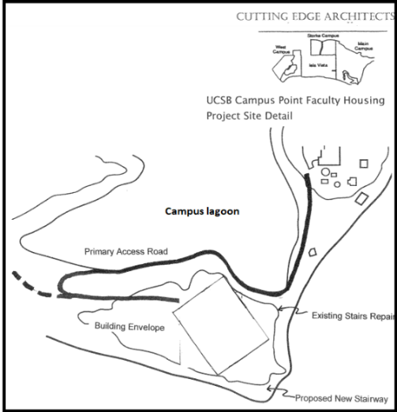
Figure 2.2b Habitat Restoration Sites
Figure 2-2a Project Location
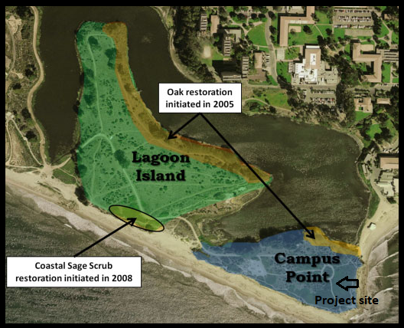
Image from: Lagoon Island & Campus Point | CCBER (ucsb.edu)
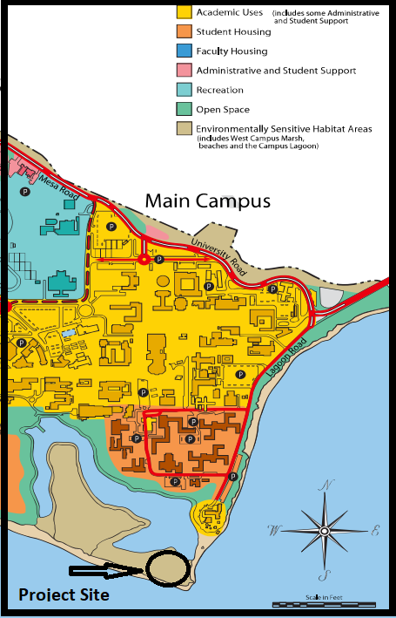
Image from UCSB LRPD
Figure 2.2b Surround Land Uses
2.3 Project Construction
2.3.1 Phasing
Preliminary construction, including rough grading and site preparation, would occur over approximately 4 months. It is reasonable to assume that the construction of the 3-story structure would occur over the next 12-14 months (stella, 2020 ). Construction would begin in early May when there is the least chance of rain during the construction period in which grading will occur. Equipment to be used on-site during construction would include, but not limited to, bulldozers, excavators, backhoe loaders, transportation and trucks, cranes (Unit Condominium Housing Project example.pdf).
2.3.2 Access
Access to the project site for the use of construction equipment would be along Lagoon road. The dirt road entrance would be used as a staging area during site grading and preparation (see figure 2-3-2).
A concrete sea wall of approximately 10- to 20-feet long would be constructed along section 1 of the road, between the coast and the road south east of the proposed project site. A Retaining wall of approximately 910-920 feet long would be placed between the lagoon and the proposed extension road (See figure 2.4.2). A wooden fence would be built along the bluff for safety measures.

2.3.3 Grading and Site Preparation
Development of the proposed project would include grading, including a cut of approximately 112,500 cubic feet to build the road that wraps around the lagoon (section 2) of road on figure 2.4.1). This reasonably assumes a 25-foot horizontal cut to widen the 5-foot dirt road and a 15-foot vertical cut to account for the slope being constructed on. Excess soil from the grading will be used to fill the lagoon and section one of the proposed road to widen the land to 30 feet to fit the road.
The excavation for Section 2 of the road would require removing oak trees located in CCBER’s Oak restoration site. Trees that can be relocated will be planted elsewhere on the project site. Replacement trees will be placed off-site in CCBERG’s oak restoration site located on Lagoon Island (see Figure 2.3a). The excavation for the road where it curves away from the lagoon would require removing a Monterey Pine. All vegetation, which primarily consists of ice plant, along the project envelope would be removed.
2.3.4 Project Envelope
Construction of the 3-story, 36 feet tall, building and parking lot would occur immediately following site preparation and grading. The residential building would have a white stucco fence with wrought iron rimming its top. The gate would be a wrought fence enclosing the building and parking lot with rock pillars. Along the structure, native, drought-tolerant vegetation would be planted. A wooden fence would be placed along the bluffs in the project vicinity. Trails would connect the project site to the existing paths that go around the lagoon.

Figure 2.3.2 Access Road
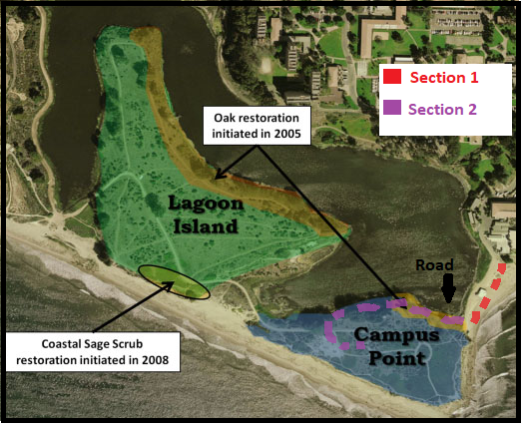
Map from: UCSB CCBER

2.4 Project Operations
The proposed project is going to a Spanish-style building painted white with Barrel roof tiling (see figure 2-4). The architecture will incorporate archways and rectangular windows. A few of the units will have small balconies (RRM Design Group).
The bottom floor would be open to students from 7:30am to 9:00pm from Monday to Friday when classes generally are in session. After 9:00 pm the gates will be closed, and the facility will only be open to faculty residents. Based on the security concerns regarding faculty housing, it is reasonable to assume that a badge will be needed to enter the facility after the bottom floor closes.
Figure 2-4a Project Design

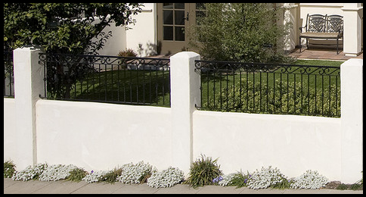
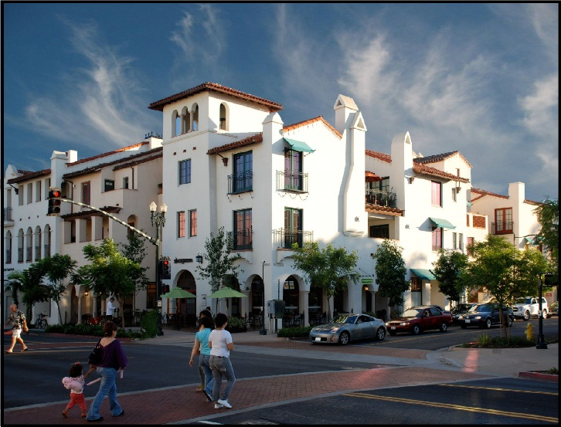
Figure 2-4b Fence Option 1
Image From: marylyonarts.com
Image from: https://www.rrmdesign.com/project/paseo-chapala/

.
Figure 2-43: Fence Option 2
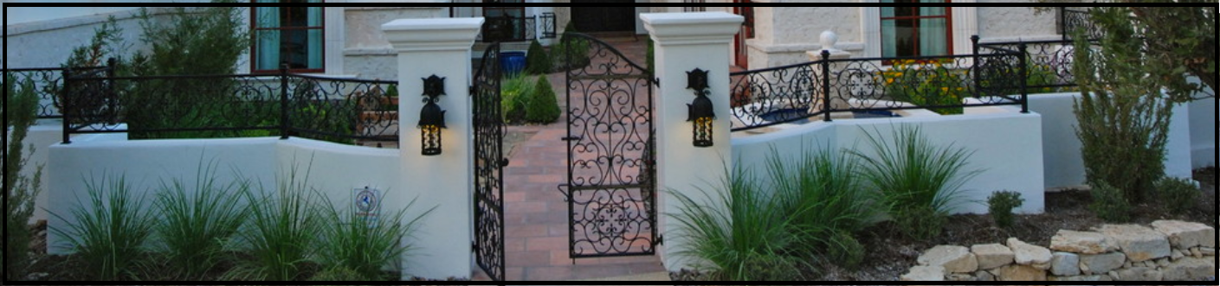
Image from: Custom Homes - Mediterranean - Exterior - Austin - by A-Design By Gustavo Arredondo, Inc. (houzz.com)
3.0 ENVIRONMENTAL SETTING
Section 3.0 Environmental Setting will provide background information on existing conditions relating to Biological resources. This section will cover 3.1 regional environmental settings and 3.2 relevant regulatory frameworks to provide a baseline that would be impacted directly or indirectly from the proposed project. The Regional Environmental setting provides a brief description of the project location and terrain then discusses surrounding land uses and land use designations to provide context environmental compatibility. Section 2 discusses relevant federal, state, and local regulations and policies pertinent to Biological Resources.

3.1 Regional Environmental Setting
The project site is in southern Santa Barbara County within Campus Point, located on the eastern portion of the University of California Santa Barbara (See figure ….). The community of Isla Vista is adjacent to the UCSB campus. Regional access to the project is provided by US 101, located approximately 3 miles from the proposed project site. Local access is via Mesa Road, when coming from Isla Vista, and SH 217 Ward Memorial boulevard when coming from the south. Both routes lead to Lagoon Road, which ends where the proposed extension of the road begins.
The terrain is both relatively flat and moderately sloped. The topography within the project building envelope and part one of the proposed road is relatively flat. There is an approximately 60 percent slope in between the edge of the lagoon and the coastal bluff where the project site is located.
3.1.1 Surrounding Land Use
North
North of the project area is the UCSB campus, which consists of student housing, academic, Environmentally Sensitive Habitat Area (ESHA), recreational, and administrative land uses (see Figure 3.1.1a).
West
West of the campus is the community of Isla Vista, which consists of residential, retail, commercial, professional institutional, and recreational land uses (County of Santa Barbara 2001) (see figure 3.1.1b).
South and East
South and east of the proposed project is the Santa Barbara channel. The Santa Barbara channel is the strip of water located between Santa Barbara County and the Channel Islands.
3.1.1.1 Campus Lagoon
The project site is situated between the UCSB Campus Lagoon and the Santa Barbara Channel (ranging from the Channel Islands and west coast). This EIR will focus on Biological resources within the project area, the Campus Lagoon and Lagoon Island,
The lagoon is approximately 30-acres in surface and 4-feet deep. It has been modified to have brackish water (see figure 3.1.1.1a). Under the UCSB Long Range Development Plan, the lagoon is designated as an ESHA because of the special status species it supports (see Table 3.1.1.1). The lagoon is designated as wetland habitat. Wetlands subject to section 494 of the Clean Water Act are defines as:
“areas that are inundated or saturated by surface or ground water at a frequency and duration sufficient to support, and that under normal circumstances do support, a prevalence of vegetation typically adapted for life in saturated soil conditions. Wetlands generally include swamps, marshes, bogs, and similar areas.”
There have been several conservation efforts made in the lagoon including:
- Shorebird habitat islands and salt marsh restoration. small islands in the Campus Lagoon were created for salt marsh and shallow water habitat for shorebirds in 1995. The small islands attracted over 100 birds.
- Lagoon Point restoration. 0.25-acres of non-native annual grasslands was converted to native coastal sage scrub in 2006.
3.1.1.2 Lagoon Island
Lagoon island is located within the same land designated as open space and ESHA as the proposed project (see figure 3.1.1.2). There have been multiple restoration and conservation efforts made in this location:
- The East Depression Restoration. This project and is a student class project with the Cheadle center of biological and ecological restoration (CBBER) that began in 2001. It has restored 0.5 acres of coastal dune vegetation and the removal of invasive Iceplant through salinization.
- Prescribed Burn. A 0.7-acre prescribed burn was conducted by CCBER From 2006 to 2008 to facilitate restoration of the area and reduce non-native species' environmental impact.
- Live Oak Restoration planting. over 1,000 acorns were planted In 2005 under the direction of CCBER; over 700 of them grew to juvenile trees.
- Ice plant solarization: Beginning in 2008, CCBER has solarized non-native Iceplant In 2005. Solarization is a process that traps heat and blocks sunlight, killing the Iceplant. This effort is still ongoing (https://www.ccber.ucsb.edu/ecosystem/management-areas-campus-lagoon/lagoon-island-campus-point)

3.1.2 Project Site
The project site is designated as open space under the UC Santa Barbara LRDP and primarily consists of coastal shrub habitat. The project site is also designated as an ESHA under the LRDP (see figure 3.1.2). The LDDP designates areas as ESHA because they “contain plant or animal life which is either rare or especially valuable because of their special nature or role in an ecosystem and could be easily disturbed or degraded,” (California Coastal Act Section 30107.5). Within the ESHA that the project site is located, several native plants are found Conservation efforts include:
- Live Oak Restoration planting. CCBER planted around 80 acorns in 2005 to restore oak tree population (CCBER).
- Ice plant solarization: Beginning in 2008, CCBER has solarized non-native Iceplant in 2005. Solarization is a process that traps heat and blocks sunlight, killing the Iceplant. This effort is still ongoing (https://www.ccber.ucsb.edu/ecosystem/management-areas-campus-lagoon/lagoon-island-campus-point)
- Prescribed Burn. A prescribed burn was conducted by CCBER From 2006 to 2008 to facilitate restoration of the area and reduce non-native species' environmental impact.

Fauna and Flora
Five vegetation communities/land cover types that exist at the proposed project site; oak woodland, coastal sage scrub, saltwater marsh and coastal dune.
Oak Woodland and Forrest
There are three types of trees oak trees typically found within the Santa Barbara County: Valley Oak, Coastal Oak, and Blue Oak. Principle characteristics that define the type of woodlands are the density, species, number, and relationship between trees and understory. Oak habitats support diverse wildlife populations (UCSB thresholds manual, 2021). Oak habitats offer shelter, nesting, food storage sites, and food to other species. Some species associated with oak woodland habitats include redberry, coffeeberry, toyon, mistletoe, poison oak, forbs, and grasses. There are currently, there are two coastal live oak groves located on Campus Point and Lagoon Island. In 2009 CCBER Panted In 2005 planted around 80 acorns (CCBER).
Coastal Sage Scrub
Soft-leaved, shallow-rooted sub-shrubs characterize coastal sage scrub. It is a Mediterranean-drouthy tolerant environment (UCSB LRDO, 2020). Much of the campus point coastal sage scrub habitat is covered with ice plant. In 2009 CCBER began planting native coastal scrub species and solarization.
Saltwater Marsh
Wetlands are one of the most biologically productive habitats and include coastal salt and brackish marshes, vernal pools, and freshwater marshes (UCSB Thresholds manual 2021). The Campus Lagoon supports four environmentally sensitive species and a variety of bird species (see table 3.1.2 and figure 3.1.2b)
Coastal Dune
Coastal dunes develop when substantial amounts of dry sand are blown and are affected by wind, current, and tidal inundation. The UCSB coastal dunes support the Wandering Skipper, the Pygmy Blue Butterfly, Dune Beetles, and Belding’s Savannah Sparrow. The Belding’s Savannah Sparrow is a non-migratory bird that resides near the Goleta slough and comes to the Campus Lagoon in winter. It is listed as state endangered. The Wandering Skipper is considered a species of concern due to habitat loss (UCSB CCBER)
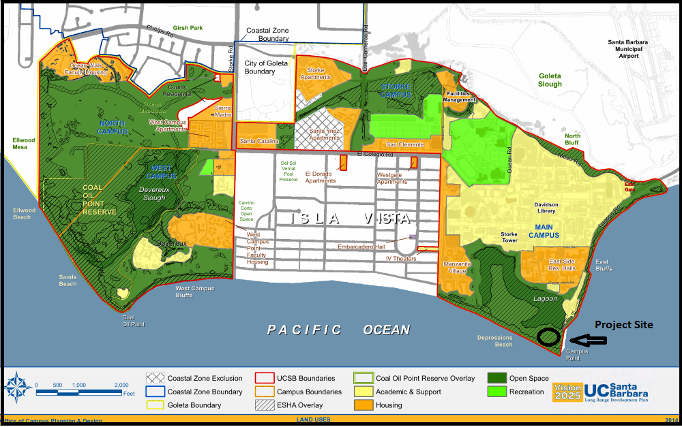
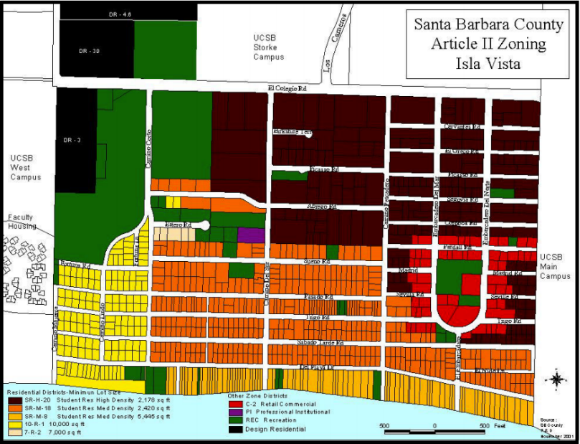
Image from UCSB LRDP
Figure 3.1.2a UCSB Land Use Map
Figure 3.1.1b Isla Vista Land Use Map

Image from: iv_zoning_nov_01.PDF (countyofsb.org)
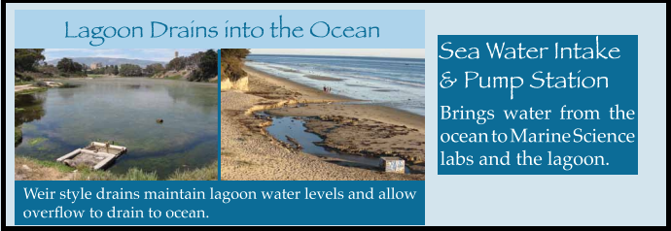
Image from: CCBER
Figure 3.1.1.1a Lagoon Drainage

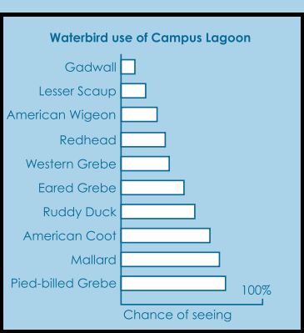

Figure 3.1.1.1a Waterbirds use of Campus Lagoon
Image from: CCBER

Table 3-1a Special Status Species Found at the Campus Lagoon
Latin Name | Common Name
Abronia Martima | Red Sand Verbena
Malacothrix | Dunedelion
Lashenia glabrata ssp. coulteri | Coulter’s goldenfields
Passerculu sandwhichensis beldingi | Belding’s Savannah Sparrow
Information from: https://www.ccber.ucsb.edu/ecosystem/management-areas/campus-lagoon

Table 3-1b Native Plant Species Found on Lagoon Island & Campus Point
Latin Name | Common Name
Ambrosia psilostachya | Western Ragweed
Artemisia californica | California sagebrush
Atriplex californica | California saltbush
Baccharis pilularus | Coyote brush
Bromus carinatus | California brome grass
Cammisonia cherianthifolia | Beach evening primrose
Croton californicus | California croton
Encelia californica | California sunflower
Eriogonum parvifolium | Seacliff buckwheat
Eriophyllum confertiflorum | Golden yarrow
Eschscholzia californica | California poppy
Gaura coccinea | Scarlet beeblossom
Gnaphalium canescens | Wright's cudweed
Gnaphalium californicum | California everlasting
Isocoma menzesii | Coast goldenbush
Leymus triticoides | Alkali rye
Lotus scoparius | Deer weed
Lupinus arboreus | Coastal bush lupine
Lupinus bicolor | Miniature lupine
Malacothrix saxatilis | Cliff aster
Mimulus aurantiacus | Monkey flower
Quercus agrifolia | Coast live oak
Scrophularia californica | Bee plant
Suaeda taxifolia | Seablite
Table from: https://www.ccber.ucsb.edu/ecosystem/management-areas-campus-lagoon/lagoon-island-campus-point
3.2 Regulatory Framework
Several Federal, State, and local regulations have been established to conserve and protect biological resources. The following section provides descriptions of regulations and policies applicable to biological resources within or adjacent to the project site.
3.2.1 Federal Regulations
Federal Endangered Species Act (U.S.C. Title 16, Chapter 35, Sections 1531-1544): The Endangered species act (ESA) provides a framework for the protection and recovery of “imperiled species and the ecosystems upon which they depend” (Fish and Wildlife Services, 2020). ESA prohibits “take” of listed or endangered species and their habitat. “Take” is defined as “to harass, harm, pursue, hunt, shoot, wound, kill, trap, capture or collect, or to attempt to engage in any such conduct” (4.3_Biological Resources.pdf). An endangered species is “a species is in danger of extinction throughout all or a significant portion of its range” (Fish and Wildlife Services, 2020). A threatened species is a “species is likely to become endangered within the foreseeable future” (Fish and Wildlife Services, 2020).
Clean Water Act (CWA): The Federal Water Pollution Control Act was enacted in 1948 and then expanded upon in 1972. The act then became known as the Clean Water Act. The CWA established establishes the basic structure of regulations of pollutants into the water of the U.S Section 404 of CWA establishes a program to regulate the discharge of dredged or fill material onto waters, including wetlands (Environmental Protection Agency, 2021).
3.2.2 State Regulations
The California Endangered Species Act (CESA): The CESA protects and conserves plant and animal species that the California Fish and Game Commission (CDFW) designates as threatened or endangered (Fish and Wildlife Services, 2020). The Act requires proper authorization for a CESA-listed species to be “imported into the state, exported out of the state, “taken” (California Department of Fish and Wildlife). Taken is defines under the California Fish and Game code as killed possessed, purchased, or sold (California Department of Fish and Wildlife).
California environmental Quality Act: CEQA aims to disclose environmental impacts to the public and prevent or reduce environmental impact from a project (California Department of Fish and Wildlife). Under CEQA, sensitive plants and animals receive consideration in addition to state-listed species. Sensitive species include wildlife species of special concern (SSC) and plant species listed on the California Native Plant Societies (Trinity Cannabis Cultivation and Management draft EIR, 2018)
The Coastal Act: The Coastal Act created a federal coastal zone and established coastal management policy by requiring local governments to adopt a Local Coastal Program ((Fish and Wildlife Services, 2020).
Section 30107.7 of the Coastal Act labels ESHA as "any area in which plant or animal life or their habitats are either rare or especially valuable because of their special nature or role in an ecosystem and which could be easily disturbed or degraded by human activities and developments." Section 30240 states that "Development in areas adjacent to environmentally sensitive habitat areas and parks and recreation areas shall be sited and designed to prevent impacts which will significantly degrade those areas, and shall be compatible with the continuance of those habitat and recreation areas" (CA.gov 2021).The Act restricts development within ESHAs to "only those uses that are dependent on the resource, and requires that ESHAs be protected against significant disruption of habitat values" (CA.gov 2021).
Native Plant Protection Act (NPPA): The NPPA is regulated by the CDFW and aims to “preserve, protect, and enhance rare and endangered plants in this state.” This act gave the California Fish and Game Commission the authority to designate native plants as endangered or rare (Sierra Forest Legacy, 2008)
3.2.3 Local Regulations
The following local regulations pertaining to biological resources are taken from the Santa Barbara County Coastal Plan and the UCSB LRDP.
Coastal Land Use Plan Policy 9-35: “Oak trees, because they are particularly sensitive to environmental conditions, shall be protected. All land use activities, including cultivated agriculture and grazing, should be carried out in such a manner as to avoid damage to native oak trees. Regeneration of oak trees on grazing lands should be encouraged”
Coastal Land Use Plan Policy 9-36: “When sites are graded or developed, areas with significant amounts of native vegetation shall be preserved. All development shall be sited, designed, and constructed to minimize impacts of grading, paving, construction of roads or structures, runoff, and erosion on native vegetation. Grading and paving shall not adversely affect root zone aeration and stability of native trees.”
Coastal Land Use Plan Policy 9-9: “A buffer strip, a minimum of 100 feet in width, shall be maintained in natural condition along the periphery of all wetlands. No permanent structures shall be permitted within the wetland or buffer area except structures of a minor nature, i.e., fences, or structures necessary to support [light recreation]” (SB Coastal Land Use Plan, 2019)
Coastal Land Use Plan Policy 9-14: “New development adjacent to or in close proximity to wetlands shall be compatible with the continuance of the habitat area and shall not result in a reduction in the biological productivity or water quality of the wetland due to runoff (carrying additional sediment or contaminants), noise, thermal pollution, or other disturbances.”
3.2.4 UC Santa Barbara LRPD Policies
The LRDP Has several policies meant to protect open space and ESHAs. A few of the policies that relate to the proposed project are stated below.
Policy ESH-29. “Trees located within ESHA or designated Open Space shall not be trimmed or removed unless determined by a certified arborist to pose a substantial hazard to life or property and authorized pursuant to an emergency permit, or where the proposed removal is part of a Commission-approved habitat restoration plan and shall require a Commission-approved Notice of Impending Development.”
Policy ESH-30. “New development shall avoid all special-status plant species, […] to the greatest extent feasible. This policy applies to isolated individual plants that do not meet the definition of ESHA. Special-status species that are ESHA shall be afforded full protection under the ESHA provisions of the LRDP. Where the individual(s) do not meet the definition of ESHA and cannot be feasibly avoided, then it may be relocated provided that the impact to individual species shall be fully mitigated” (UCSB LRDP 2017).
Policy ESH-32. “ESHA buffers and wetland buffers shall be planted with locally native species that are appropriate to protect and enhance the adjacent ESHA or wetland” (UCSB LRDP 2017).
Policy ESH-35. To protect the Campus Lagoon and Island, any new development adjacent to the lagoon shall:
- Landscape the perimeter of the development predominately with native shrubs and trees;
- Orient lighting to minimize light and glare to the Lagoon and tree-covered bluff s as outlined in Policy ESH-15; and
- Provide a minimum setback of 150 feet from the ocean bluff top”

4.0 IMPACTS ANALYSIS
4.1 Significant Criteria
The following section list significant thresholds for biological resources under CEQA Appendix G and relevant County thresholds identified in the Santa Barbara county thresholds manual.
4.1.2 CEQA Appendix G Criteria
CEQA Appendix G states that a project will normally have a significant effect on the environment if it will (CEQA Appendix G section):
- Have a substantial adverse effect, either directly or through habitat modifications, on any species identified as a candidate, sensitive, or special status species in local or regional plans, policies, or regulations, or by the California Department of Fish and Wildlife or U.S. Fish and Wildlife Service?
- Have a substantial adverse effect on any riparian habitat or other sensitive natural community identified in local or regional plans, policies, regulations or by the California Department of Fish and Wildlife or U.S. Fish and Wildlife Service?
- Have a substantial adverse effect on state or federally protected wetlands (including, but not limited to, marsh, vernal pool, coastal, etc.) through direct removal, filling, hydrological interruption, or other means?
- Interfere substantially with the movement of any native resident or migratory fish or wildlife species or with Conflict with any local policies or ordinances protecting biological resources, such as a tree preservation policy or ordinance?
- established native resident or migratory wildlife corridors, or impede the use of native wildlife nursery sites?
- Conflict with the provisions of an adopted Habitat Conservation Plan, Natural Community Conservation Plan, or other approved local, regional, or state habitat conservation plan?
4.1.3 Santa Barbara County Thresholds
The Santa Barbara County’s Environmental Thresholds Guidelines Manual states that potentially significant impacts relevant to the project would occur if development of the Project site would:
- “Projects which result in a net loss of important wetland area or wetland habitat value, either through direct or indirect impacts to wetland vegetation, degradation of water quality, or would threaten the continuity of wetland dependent animal or plant species are considered to have a potentially significant effect on the environment (California Environmental Quality Act: Guidelines, Appendix G; items c, d, and t).
- Project created impacts may be considered significant due to changes in [woodlands] habitat value and species composition such as the following:
- Habitat fragmentation.
- Removal of understory.
- Alteration to drainage patterns.
- Disruption of the canopy
- Removal of a significant number of trees that would cause a break in the canopy or disruption in animal movement in and through the woodlands
In general, the loss of 10 percent or more of the trees of biological value on a project site is considered potentially significant.

4.2 Project Impacts
Potentially significant impacts on biological resources resulting from the construction and operations of the proposed project are discussed below.
4.2.1 Construction Related Impacts
Impact BIO-1: Construction activities relating to construction of part two of the access road would remove mature coastal live oak trees, which are identified as a special species under regional plans.
Construction of Section 2 of the access road would remove seven mature coastal life oak trees The UCSB LRDP Coastal land use Policy 9-35 states that oak trees “shall be protected” (UCSB LRDP 2017). According to the policy, all land-use activities should avoid damage to native oak trees. Furthermore, the county of Santa Barbara biological resource thresholds states that if a project impacts on woodland and forest habitat “may be considered significant” if the project results in the removal of a significant number of trees that would cause a break in the canopy” (UCSB thresholds Furthermore, the grading associated with the construction of the proposed project would also adversely impact oak trees by disturbing the oak tree roots. Oaktree roots 18 inches under the soil and can spread four to seven times the width of the tree’s crown (Simpson 2018). The removal and disturbance of the oak trees would result in a potentially significant impact on biological resources
Mitigation Measures and Residual Impacts
The applicant’s project description includes the following mitigation measure on biological resources: All trees to be removed shall be replaced by one specimen of the same species
This measure is modified to account for LRDP regulations and increase the reduction of proposed impacts on biological resource:
MM BIO-1: Tree Replacement Plan. To compensate for the removal of Coastal Live Oak and Monterey cypress trees, a Tree Replacement Plan shall be prepared by a P&D approved arborist or biologist and shall include;
- replacement tree locations;
- Tree or seedling size replanting speciﬁcations as follows;
  - The removal of the cypress trees requires 3:1 replacement with native trees;
  - For every Live Coastal Oak tree removed, 10 replacement Oak seedlings, less than a year old, grown from acorns collected in the area must be planted on-site, or within the designated Open space the proposed project is in;
- a ﬁve year monitoring program with species performance standards to ensure that the replacement planting program is successful;
- Oak tree plantings shall be supplemented with a mycorrhizal inoculant, preferably oak leaf mulch or from clippings of locally indigenous species lawfully removed from the site or from sites within the vicinity of the planting site at the time of planting to help establish plants.
.
MM BIO-1b: Arborist Report Requirement. The applicant shall hire a UCSB Office of Planning and Research approved arborist or biologist to evaluate all native tree and shrub removal within 25 feet of potential ground disturbance. Species shall present biologically favorable options for access roads, utilities, drainages, and structure placement considering native tree and shrub species, age, and health with preservation emphasized. All development and potential ground disturbances shall be designed to avoid the maximum number of native species as possible.
Residual Impacts. Incorporation of measure MM BIO-1, which implements the requirements of LRDP EIR mitigation measure BIO-3D, would reduce impacts resulting from the removal of mature trees with biological importance from the project site to less than significant (Class ll).

Impact BIO-2: The construction of the access road, the three-story structure and operations of the proposed project would adversely affect CCBER local ecological restoration efforts.
The construction of the proposed project and its operations would directly conflict with CCBER’s ecological restoration of oak woodland and coastal sage scrub. As stated earlier, the construction of part two of the access road would remove coastal oak trees planted by CCBER in 2005 during their Oak restoration initiative. The three-story structure is located at the campus point where CCBER is in the process of ice plant solarization removal and native planting. While the placement of the three-story structure is proposed in a site dominated by invasive ice plant, surrounding landscaping and access points would potentially impact CCBES native planting initiatives, which aim to replace the ice plant with native species.
Furthermore, the UCSB LRPD gives CCBER the authority to retain, repair, and maintain their designated restoration effort sites (UCSB LRDP).
Mitigation Measures and Residual Impacts
MM BIO-2a: Landscaping Plan. The landscaping shall utilize native plants and seed stock from locally obtained sources. The landscaping shall:
- Utilize plants found in campus point and lagoon island (see table 3-1b).
- Coastal sage scrub
- Align with CCBER’s ecological restoration efforts to the greatest extent feasible
The Applicant shall incorporate these requirements into a landscape plan to be prepared by a UCSB Office of Planning and Research approved landscape architect or arborist.
MM BIO- 2b: Beneficial Ecological Restoration Project. To compensate for the lagoon’s loss of surface area resulting from the widening of the Section One of the proposed access road, the applicant shall implement an Ecological Restoration Project including:
- A minimum 1:1 mitigation ratio of restoration habitat area to the surface area of the lagoon lost to landfill
- Consistent with the County’s biological performance standards in the County’s environmental thresholds.
- Align with CCBERG lagoon restoration efforts
- Use appropriate native species from the local habitat area and/or seed stock when feasible.
- Enhance the habitat of land surrounding the lagoon

Residual Impacts. Incorporation of mitigation measure MM BIO-2 would feasibly align with local preservation efforts conducted by CCBER, such that impacts on biological resources would be reduced to less than significant (Class ll).
Impact BIO-3: Construction activities relating to the construction of the road and three-story structure would adversely affect sensitive species that inhabit the Lagoon through increased sedimentation and erosion.
This project has the potentially to “have a substantial adverse effect on state or federally protected wetlands (including, but not limited to, marsh, vernal pool, coastal, etc.) through direct removal, filling, hydrological interruption, or other means.”
This Guideline is further detailed in the UCSB LRDP stating “projects which result in a net loss of important wetland area or wetland habitat value, either through direct or indirect impacts to wetland vegetation, degradation of water quality, or would threaten the continuity of wetland dependent animal or plant species are” considered to have a potentially significant effect on the environment.
Construction of the access road would have adverse impacts to sensitive species supported by the campus lagoon. The road construction would have the potential to result in additional pollutants into the water from construction dust which could potentially alter the temperature, oxygen from algae blooms associated with nitrogen levels from polluting sources. These changes can alter the number of wildlife species and the diversity of species supported by the lagoon.
Based on my evaluation of the project site it is reasonable to assume that the construction of Section 1 of the access road requires landfill in the lagoon to widen the area to fit 30 ft wide road. This account for the road having two lanes and adequate room for pedestrians and bicyclists to also use the road. This would reduce the lagoon’s surface area and would potentially change the soil and water salinity and water level.
Runoff from pollutants generated during construction of the road also has the potential to adversely impact the lagoon. Runoff could include toxic elements such as construction equipment oil and grease.
The additional human activity resulting from the building’s academic and residential use has the potential to disrupt animals’ behavior due to the noise and other physical elements.
Mitigation Measures and Residual Impacts
MM BIO-3a: Standard Erosion and Sediment Control Plan. To minimize potential sedimentation into the lagoon, the applicant shall develop an Erosion and Sediment Control Plan (ESCP) to be implemented as part of the project Grading and Erosion and Sediment Control Plans designed to minimize erosion during construction. They shall be implemented for the duration of the grading period (Santa Barbara Erosion and Sedimentary Plan, 2012)
As in accordance with the Santa Barbara Building and Safety Division, the ESCP shall include the following:
- Required Best Management Practices. The following BMPs for soil erosion and sediment control shall be used, as applicable:
- Gravel Construction entrance;
- Sediment filters/barriers;
- Silt fences;
- Plastic sheeting; and
- Wet weather measures.

- Additional Erosion Control Measures. The following erosion control measures shall be implemented:

- Water down project grading area to prevent dust from leaving the site;
- Wet down entire area of disturbed soil during the early morning hours and at the end of the day;
- Keep all areas of vehicular movement damp throughout the construction to reduce dust
- Place tarps on dump trucks to limit dust during transport of dirt on and off-site; and
- All alleyways, circulation routes, haul routes, streets, and sidewalks shall be kept clean and clear of dirt, dust, and debris.
- “Protection Measure Removal. The erosion prevention and sediment control measures shall remain in place and be maintained in good condition until all disturbed soil areas are permanently stabilized.”

- “Standard Erosion Control Measures Submittal Requirements. The plans sheets for a Standard Erosion Control Plan shall include the following information:

- Specific measures to be installed
- Specific locations where measures will be installed.
MM BIO-3b: Equipment Storage-Construction. To prevent contamination from discharging to the storm drains, street, drainage ditches, creeks, or wetlands, the applicant shall designate a construction equipment filling and storage area within the project envelope. The Area shall be no larger than 50 by 50 Feet and be located 100 feet from the Campus lagoon.
MM BIO- 3c: Beneficial Ecological Restoration Project. To compensate for the lagoon’s loss of surface area, resulting from the widening of the part one of the proposed roads, the applicant shall implement a Beneficial Ecological Restoration Project with a minimum 1:1 mitigation ratio. The project shall:
- Have a minimum 1:1 mitigation ratio to the surface area of the lagoon lost to landfill
- consistent with the County’s biological performance standards in the County’s environmental thresholds.
- Align with CCBERG lagoon restoration efforts
- use appropriate native species from the local habitat area and/or seed stock when feasible.
- enhances the land surrounding the lagoon
Residual Impacts. Implementation of BIO-3 would not feasibly mitigate the net loss of important wetland habitat due to the loss of the Lagoon surface area. The residual impact on biological resources would remain significant (Class I).
4.2.2 Operational Use Impacts
Impact Bio-4: The operational use of the proposed project would potentially result in increased water discharge containing pollutants such as pesticides, herbicides, and associated urban runoff into the lagoon, resulting in degradation of water quality and altering the habitat for salt marsh-dependent species ESHA.
Due to the proximity of the lagoon and project site, it is reasonable to assume that there would be an increase in pollutants in the runoff that drains into the water during the project’s operational use. It is also reasonable to assume that the access road’s construction would remove existing vegetation and increase the amount of impervious surface at the project site. This would increase the quantity and affect the quality of stormwater runoff reaching the Campus lagoon. Pollutants from herbicides, pesticides, oils, grease, and other urban-associated water runoff would potentially degrade the water quality in sensitive wetland habitats at the Campus lagoon. This would have an adverse effect on the species special status species that reside within or in the vicinity of the lagoon
This project would have the potential to “have a substantial adverse effect, on any species identified as, sensitive and special status species through habitat fragmentation, which would potentially result in a significant impact.
Mitigation Measures and Residual Impacts
MM BIO-4: Storm Water BMPs. To minimize pollutants impacting downstream waterbodies or habitat, the applicant shall utilize Best Management Practices (BMPs) for the parking lot and paved access road. BMPs could include:
- vegetated filter strips
- bioswales
- bioretention areas.
Residual Impact. Incorporation of MM BIO-4: would feasibly reduce degradation of water quality resulting from pesticides, herbicides, and associated urban runoff, such that impacts on biological resources would be reduced to less than significant.

Impact Bio-5: The operations of the project associated with residential housing and utilization of the classrooms in the open space that is classified as environmentally sensitive habitat by the UCSB LRDP would result in habitat modification, both directly through altering the land classification of the land use and indirectly through increased human presence, which would potentially result in a substantial adverse effect on special status species within the vicinity of the proposed project

The proposed project site is designated as Open space EHSH due to the number of native and special status species it supports. There are several policies restricting development within or adjacent to ESHA. Converting land designated as ESHA into residential use would limit protections for the sensitive species inhabiting the area.
Furthermore, humans’ additional presence within Campus Point and adjacent to the Campus Lagoon and Lagoon Island could indirectly impact sensitive species within the areas. It is reasonable to assume that additional lighting, pollution, and noise may impact species within the ESHAs. The conversion of the habitat into anthropogenic use affects the habitat’s quality for the species residing there (South Kellogg Building Material/Recycling facility EIR 2011). It is reasonable to assume that there will be an increase in plants being trampled and animals getting into garbage and possibly getting sick. Animals would be limited in their movement because additional people are utilizing the space. The quality of the habitat would decline. The conversion of ESHA land and increased human presence would potentially have a substantial adverse effect on sensitive and special status species, resulting in a significant impact.
Mitigation Measures and Residual Impacts
MM BIO-5a: Ecological Restoration Plan. To compensate for the loss of surface area of the lagoon, resulting from the widening of the part one of the proposed roads, the applicant shall implement a Ecological Restoration Plan with a minimum 1:1 mitigation ratio. The project shall:
- Have a minimum 1:1 mitigation ratio to the surface area of the proposed access road and project envelope.
- Align with CCBERG lagoon restoration efforts,
- Use appropriate native species from the local habitat area, and/or seed stock when feasible. Local habitat areas could be buying saplings from a local nursery or using seeds within the vicinity of the project site. This would mean from Campus point or Lagoon Island
- Be implemented in Lagoon island, Campus Point, or within the buffer surrounding the lagoon.

MMBIO-5b: Landscaping Plan. The landscaping shall utilize native plants and seed stock from locally obtained sources. The landscaping shall:
- Utilize plants found in campus point and lagoon island (see table 3-1b).
- Coastal sage scrub
- Align with CCBER’s ecological restoration efforts to the greatest extent feasible
The Applicant shall incorporate these requirements into a landscape plan to be prepared by a UCSB Office of Planning and Research approved landscape architect or arborist.
MM BIO-5c: Exterior Lighting Plan. To reduce adverse impact lighting has on species occurring in the open space adjacent to the project, the Applicant shall develop an Exterior lighting plan. The plan should ensure that:
- All exterior night lighting installed on the project site is of low intensity, low glare design, minimum height, and shall be hooded to direct light downward onto the subject lot and prevent spill-over onto adjacent lots.
- Timers are installed or otherwise ensure lights are dimmed after 10 p.m
MMBIO-5d: Interpretative Signage Plan. To reduce human encroachment within the ESHA, the applicant shall develop an Interpretative signage plan. The plan shall ensure signage be provided along the northern pedestrian path. The plan shall include the following
- A map showing where the lights will go
- A description of what will be on each sign
  - Some signs shall provide information about the ESHA
  - Some signage shall encourage pedestrians to stay on the pathway and also indicate that unleashed dogs and bicycles are not permitted on the path
Residual Impacts. Implementation of MMBIO-5 would reduce human encroachment on the ESHA; however, it would not meet the necessary protections afforded to the ESHA under the ESHA provisions of the LRDP, which has “been set aside in the 2010 LRDP for permanent protection from further development” (UCSB LRDP) and does not meet any exceptions. The residual impact on biological resources would remain significant (Class I).

Cumulative Development
5.0 CUMULATIVE DEVELOPEMENT
This section addresses cumulative impacts, which refers to “two or more individual effects that are considered when taken together, or that compound or increase other environmental impacts.” according to CEQA Guidelines Section 15355.
5.1 Current Projects
For This EIR Current projects were identified using the Goleta City’s cumulative project list, the UCSB Office of Budget and Planning, and the UCSB office of Strategic Asset Management. There are currently 10 residential projects identified in the Goleta City’s cumulative project list. Below is a list of projects relevant projects within the Region of Influence of the proposed project.
5.2 Region of Influence
The concept of Region of Influence is defined as project within the vicinity of the proposed project that may increase the impacts of the proposed project.
Related projects in the Region of Influence were included in the table if they had the potential to contribute to cumulative impacts on biological resources. Project were either: located near or adjacent to coastal shrub; required the removal of protected trees; or potentially had a potential adverse impact on wetland habitat.
A list of reasonably foreseeable cumulative development projects in the Region of Influence on the UCSB campus and in Goleta is provided in Table 5-1 and 5-2. The lists include projects under construction and approved and pending tasks that are anticipated to be either under construction or operational by the time of the completion of the proposed project. Informational sources used to compile the lists were provided by the UCSB Office of Planning and Budgeting, the UCSB Office of Strategic Asset Management, and the City of Goleta.

Table 5-1a City of Goleta Cumulative Development Projects
 | Project Name | Location | Description | Project Status
1 | Village at Los Carneros | Calle Koral and Los Carneros Road | 465 residential units on 43.14 acres | Under Construction
2 | Heritage Ridge Residential Project | North of Calle Koral and West of Los Carneros | 2228 residential apartments and 132 senior apartments on 16.2 acres | Under Construction
3 | Cox Communications Building | 22 South Fairview Avenue | Removal of two buildings, and the construction of a new 6,519 square foot Telecommunications building. (2.31 acres) | Under Construction
4 | Harvest Hill Ranch | 880 Cambridge Drive | 7 lot subdivision with net of 6 homes on 4.73 acres | Under Construction
5 | Citrus Village | 7388 Calle Real | 10 residential units on 1.02 acres. | Under Construction
6 | Hollister Village Apartments | 7000 Hollister Avenue | 27 Apartments and Park on 1.84 acres | Under construction
7 | Winslowe (Formerly Old Town  Village) | South Kellogg Avenue | Mixed Use of 175 townhomes with shopkeeper/live work units on 12.31 acres. | Under Construction
8 | Highway Recycling | 909 South Kellogg Avenue | Concrete and asphalt recycling facility with temporary and permanent equipment. Includes new creek restoration, fencing, landscaping, trash enclosure, retaining wall, and drainage improvements. 11.71 acreage. | Under Construction
9 | Site Improvements | 130 Robin Hill Road | 768-sf elevator addition, and 314-sf addition to rear of building, plus a 1,100-sf new building. 3 Acres of Industrial Land use | Under Construction
10 | Cortona Apartments | 830 Cortona Drive | 176 residential units on 8.82 acres of land | Under Construction
11 | Kellogg Crossing Self Storage  (Formerly Schwan Self Storage) | 10 South Kellogg Avenue | New 136,067 SF self storage facility containing 1,043 units. 3 acreage. | Approved
12 | Bacara Beach House Relocation | 8301 Hollister Avenue | Demolition of existing beach house and relocating/constructing new beach house. 2.06 acreage. | Approved by the City; pending California Coastal Commission  action
13 | Shelby | 740 Cathedral Oaks Road | 60 residential units on 15.8 acres | Pending due to water availability
14 | Kenwood Village | Calle Real w/o Calaveras Avenue | 60 residential units on 10 acres of land | Pending due to water availability
15 | Fairview Gardens | 598 North Fairview Avenue | Master Use Permit and Special Events on 11.65 units of land | Pending - Waiting on applicant to submit revised project description.
16 | Skywest | 907 South Kellogg Avenue | 70,594 sf high cube industrial building. On 11.71 acres of industrial land | Pending selection of EIR  Consultant - On hold per applicant
17 | GVCH DPAM for  Permanent Hollipat  Parking Lot | 334 S. Patterson Ave. | Approve the existing, temporary parking lot for permanent use. 9.03 acres of offices and residential land use | Pending - CEQA review and Decisions
18 | GWSD Phelps Road Sewer Trunk Project | Within the open space area adjacent to the California Department  of Fish and Wildlife (CDFW) preserve and the western edge of Stroke | Install 1,900 feet of sewer line, install four new manholes ad abandon existing sewer line that runes through West Storke Wetland and removal of nine manholes  extending approximately 1,500 feet | Under Construction

Table 5-1b UCSB Cumulative Development Project
 | Project Name | Location | Description | Project Status
19a and 19b | Engineering III Building | East of Parking Lot 12 and north of Parking Lot 11 or West of Broida Hall encompassing the existing Broida lecture halls and trailers | 3.16 Acres of a research laboratory with labs, classrooms and offices | Planning stage
20 | Ocean Road Faculty & Staff Housing | East and west sides of Ocean Road | 543 faculty housing units on 16.7 acres | Planning stage
21 | Main Campus Residential Halls | South East of Sierra Madre and south of Noble hall where Santa Rosa Hall, Anacapa Hall, and Santa Cruz Hall, are located | 650-750 units of majority single student with some faculty housing | Planning Stage
22 | East Bluff  Stabilization Project | Coastal bluffs adjacent to lagoon road on the UCSB campus | construction of a shoreline protection device to stabilize an eroding 50-foot section of coastal bluff adjacent to Lagoon Road on the UCSB campus. | East Bluff  Stabilization  Project
23 | Classroom Building | central portion of the Main Campus.  The site is south of adjacent to the Davidson Library and the Bio Engineering Building, north of  and adjacent to the Psychology Building, and east of and adjacent to Parking Lot No. 3 . 2.4 acres | 3 story building with 53 ,700 assignable square feet and 95,250 gross square feet of floor area. The building would provide lecture halls and classrooms of various sizes, and associated support and accessory uses | Under construction
24 | GWSD Phelps Road Sewer Trunk Project | Within the open space area adjacent to the California Department  of Fish and Wildlife (CDFW) preserve and the western edge of Stroke | Install 1,900 feet of sewer line, install four new manholes ad abandon existing sewer line that runes through West Storke Wetland and removal of nine manholes. 1.4 acres  extending approximately 1,500 feet | Under Construction
25 | Arnhold Tennis Center | in vicinity of Phelps Road and Mesa Road between Pacific Oaks Drive  in the City of Goleta and Los Carneros Road on the UCSB campus, | Build 6 new tennis courts, with men’s and woman’s lockers, team meeting space and behind the court spectator seating for a minimum of 300 people on 2.1 acres of land | Under Construction
26 | Main Campus  Infrastructure  Renewal Project | Throughout UCSB main Campus | The project is proposed to correct critical infrastructure deficiencies. The project will address storm drainage, sanitary sewer, potable and reclaimed water and natural gas pipelines. | Phases 1a, 1b and 1c are complete.  Phase 2 is in construction
27 | Henley Hall | North of Phelps Hall and south of Mesa Road on the eastern portion of Parking Lot No. 12 | A permanent research facility for the UCSB Institute for Energy Efficiency comprised of laboratories, offices and a lecture hall. 1.4 Acres | Under Construction

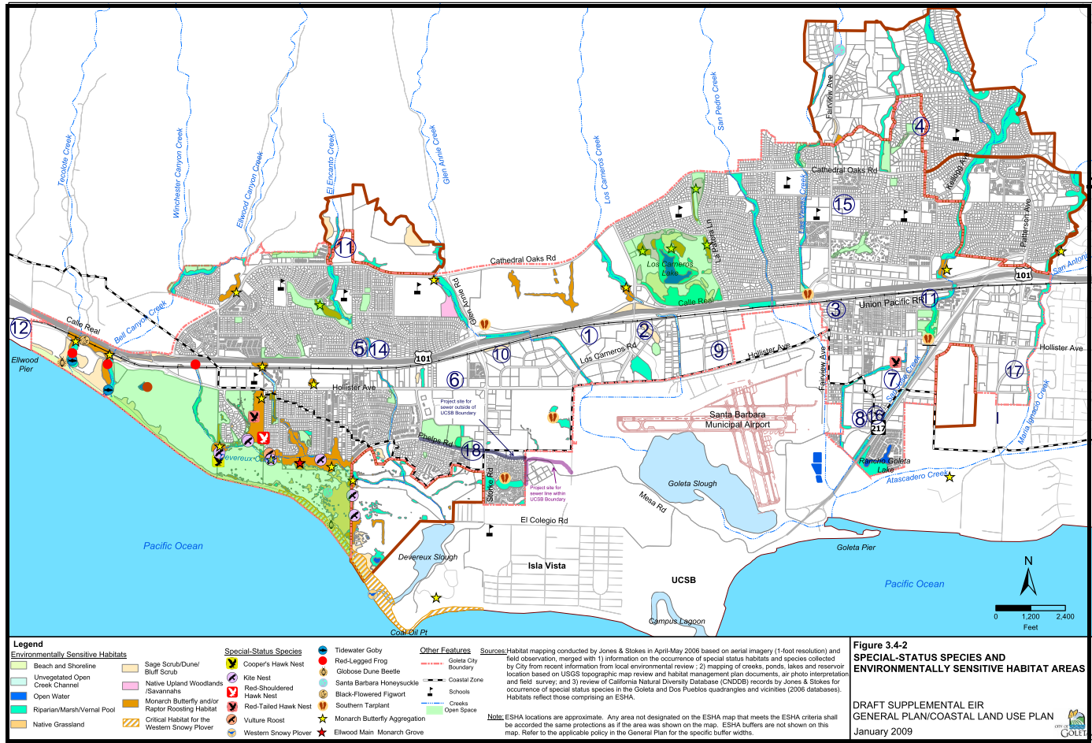
Figure 5-1a Related Projects in Goleta
Image from: UCSB LRDP

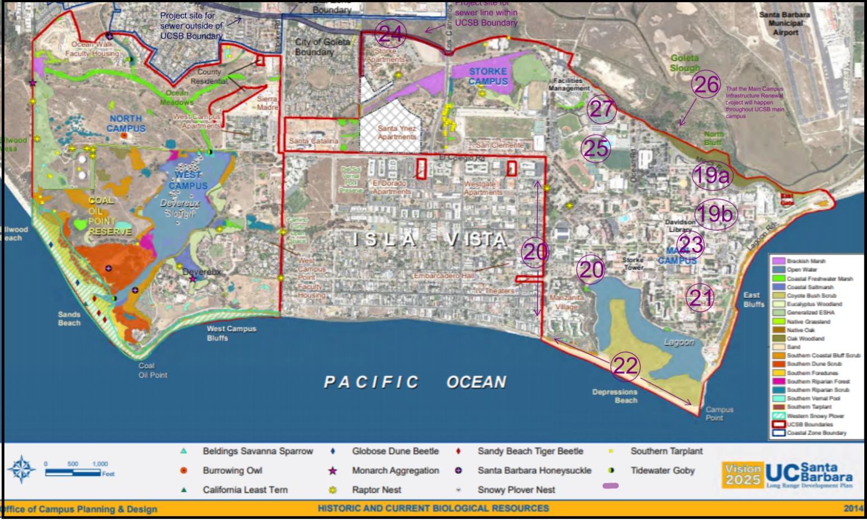
Figure 5-1b Related UCSB projects
Image from: UCSB LRDP

5.3 Cumulative Impacts
Cumulative development in the city of Goleta consists of residential development of underdeveloped land. Some of these projects include the Cortona Apartments, the Citrus Village, and Heritage Ridge, which are proposed to build on open space that hasn’t been developed. The construction and operations of the proposed project on-campus point could have the potential to have a significant cumulative impact on biological resources within the area.

Cumulative Impact to Wetlands resulting from water degradation
10 of the total projects are located adjacent to a creek or tributary and 11 projects adjacent to wetlands which potentially could potentially result in potentially significant impacts to riparian communities’ quality resulting runoff from the project site and/or immediate vicinity into off-site water bodies. Furthermore, the proposed project would have a greater impact on wetland habitats resulting from the land fill required to widen section 1 of the road.
Development of the multipurpose structure with the UCSB cumulative Impact Projects would also potentially result in significant impacts on the lagoon’s water degradation due to the proximity of the classroom entrance road and lagoon. The project is located 1,000 feet from the Lagoon (UCSB Environmental health and safety). The underground pipe to San Nicolas constructed as part of the Main Campus Infrastructure renewal Project is located 150 feet away from the Lagoon. Buildings separate Henley Hall from the Lagoon (Proposed Final ISMND 9.14.17.pdf). With mitigation measures, the UCSB cumulative projects would mitigate their impact on the water quality with having that buffer. There isn’t room to provide the 50 feet necessary buffer. And, furthermore, to construct the Lagoon, part of the Lagoon would need to be filled to allow for the Rhode’s width. These cumulative impacts would be cumulatively considerable
.

The following mitigation measures identified in the in the mitigation section of the EIR can be utilized to mitigate the impacts on water degradation resulting from runoff from construction

MM BIO-3a: Standard Erosion and Sediment Control Plan. To minimize potential sedimentation into the lagoon, the applicant shall develop an Erosion and Sediment Control Plan (ESCP) to be implemented as part of the project Grading and Erosion and Sediment Control Plans designed to minimize erosion during construction. They shall be implemented for the duration of the grading period (UCSB Sediment and Erosion Control Plan, 2012).
As in accordance with the Santa Barbara Building and Safety Division, the ESCP shall include the following:
  - Required Best Management Practices. The following BMPs for soil erosion and sediment control shall be used, as applicable:
  - Gravel Construction entrance;
  - Sediment filters/barriers;
  - Silt fences;
  - Plastic sheeting; and
  - Wet weather measures.

  - Additional Erosion Control Measures. The following erosion control measures shall be implemented:

  - Water down project grading area to prevent dust from leaving the site;
  - Wet down entire area of disturbed soil during the early morning hours and at the end of the day;
  - Keep all areas of vehicular movement damp throughout the construction to reduce dust
  - Place tarps on dump trucks to limit dust during transport of dirt on and off-site; and
  - All alleyways, circulation routes, haul routes, streets, and sidewalks shall be kept clean and clear of dirt, dust, and debris.
  - “Protection Measure Removal. The erosion prevention and sediment control measures shall remain in place and be maintained in good condition until all disturbed soil areas are permanently stabilized.”

  - “Standard Erosion Control Measures Submittal Requirements. The plans sheets for a Standard Erosion Control Plan shall include the following information:
  - Specific measures to be installed
  - Specific locations where measures will be installed.
MM BIO-3b: Equipment Storage Plan. To prevent contamination from discharging to the storm drains, street, drainage ditches, creeks, or wetlands, the applicant shall prepare an equipment storage plan that designate a construction equipment filling and storage area within the project envelope. The Area shall be no larger than 50 by 50 Feet and be located 100 feet from the Campus lagoon.
MM BIO- 3c: Beneficial Ecological Restoration Project. To compensate for the lagoon's loss of surface area, resulting from the widening of the part one of the proposed roads, the applicant shall implement a Beneficial Ecological Restoration Project with a minimum 1:1 mitigation ratio. The project shall:
- Have a minimum 1:1 mitigation ratio to the surface area of the lagoon lost to landfill
- consistent with the County’s biological performance standards in the County’s environmental thresholds.
- Align with CCBERG lagoon restoration efforts
- use appropriate native species from the local habitat area and/or seed stock when feasible.
- enhances the land surrounding the lagoon
Implementation of BIO-3 would not feasibly mitigate the cumulative loss of wetland habitat loss from this project, as it is still much greater than the projects with the spere of influence. The cumulative Impact would remain cumulatively considerable

6.0 PROJECT ALTERNATIVES
6.0 Alternatives
This Section addresses alternatives to the proposed project and examines their associated environmental impacts as required by CEQA Guidelines Section 15126, Consideration and Discussion of Alternatives to the Proposed Project. According to CEQA, an EIR shall describe a range of reasonable alternatives to a proposed project to feasibly attain most of the project's basic objectives but would avoid or lessen any of the significant effects of the project regardless of cost. CEQA Guidelines Section 15126.6(c) states that the EIR should "d briefly describe the rationale for selecting the alternatives to be discussed." The selected alternatives shall include "e sufficient information about each alternative to allow meaningful evaluation, analysis, and comparison with the proposed project" (CEQA Guidelines Section 15126(d)).
CEQA by CEQA Guidelines Section 15126 requires evaluation of the "No Project" alternative for the purpose of "[allowing] decision-makers to compare the impacts of approving the proposed project with the impacts of not approving the proposed project." The analysis requires discussion of the existing setting and "what would be reasonably expected to occur in the foreseeable future if the project were not approved." If the "No Project" alternative is determined to the superior alternative, the EIR shall identify an environmentally superior alternative among the other choices.
Based on the CEQA Guidelines. The analysis of project alternatives determines the range of alternatives based on several factors. These factors include (1) the ability for the alternative to feasibly accomplish most of the basic objectives of the proposed project, (2) the ability of the alternative to avoid or substantially lessen one or more of the significant effects, and (3) the feasibility of the alternatives.

6.1 Project Objectives
The first step in determining the reasonable range of alternatives to e analyzed is to consider the basic project objectives as previously determined in Section 2.1. These are summarized Below
- Construct a 44,000-acre mixed-use building with UCSB faculty residential units and classrooms
- Add 23 new faculty residential units
- lessen the commute between work and home
- Support recruitment and retention of faculty and staff
- meet long-term demand for affordable faculty
- provide attractive location to encourage new faculty
- Add 12 new classrooms that are
  - Allow for students and faculty to get to additional classes within 10 minutes allotted time between classes
  - to address the current and projected enrollment growth
  - increase the likelihood for students to graduate in four years, which can reduce their student debt and free up space for future enrollment
Objective No. 1 through 5 dictates the minimum size of the proposed Goleta Point Faculty Housing project and its location
- The proposed location must be large enough to provide for most of the proposed residential units and classrooms.
Objectives Nos. 1a and 2a dictate the locational requirements of the Goleta Point Faculty Housing project and its location.
- The proposed location must be located within 0.7 miles of existing UCSB classrooms to account for students and faculty's ability to walk to the classrooms within 10 minutes. This would also lessen the commute of faculty. The closest UCSB faculty housing at West Campus Point is located 1.6 miles away.

6.2 Project Alternatives Screening Criteria
The second factor to identifying a feasible range of project alternatives is to define all potentially significant impact associated with the construction and operations of the proposed project.
- Biological Resources: Removal of 5 cypress trees and mature coastal live oaks would result in the loss of state protected special status species (BIO-1); and construction of the road would possibly conflict with local restoration efforts (BIO-2); and construction of the access road and structure would potentially result in adverse impacts to sensitive species within the vicinity of the proposed project (BIO-3);, Operational use of the access road and structure would potentially result in water degradation of the lagoon (BIO-4); and the alteration of environmentally sensitive habitat potentially resulting from directly converting open space and increased human presence associated with the additional residential housing and classrooms would potentially result in the (BIO-5).
The potentially significant environmental impacts on biological resources associated with these projects are associated with its location and size within Environmentally sensitive habitat, and its constructional design. A reasonable range of alternatives include:
- Reconfiguring Project Onsite: Reconfigure the way in which the access road is built to avoid lagoon habitat loss and reduce water degradation impacts associated with the construction and construction and use of the road (see figure 6-2).
- Reduced Project Onsite: Reduce the number of classrooms and Residential units being constructed to reduce the indirect impacts on environmentally protected habitat associated with increased human presence.
- Alternative Location: Relocate the project off of campus point to avoid the impacts on the lagoon, and environmentally sensitive habitat area located within the vicinity of the current proposed site.
Figure 6-4 Project Reconfiguration
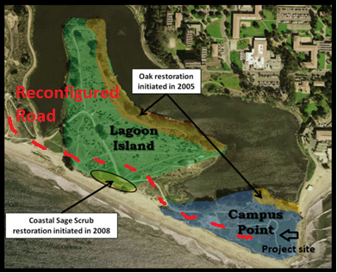

6.3 “No Project” Alternative
As defined in Section 15126.6(e), of CEQA guidelines, the “No Project” alternative:
“shall discuss the existing conditions at the time the notice of preparation is published, or if no notice of preparation is published, at the time environmental analysis is commenced, as well as what would be reasonably expected to occur in the foreseeable future if the project were not approved, based on current plans and consistent with available infrastructure and community services”
The Project existing setting is designated as Open Space with ESHA. There are currently a few trails going through the site and ecological restoration projects conducted by CCBERG taking place.
It is reasonable to expect that CCBERG would continue to conduct ecological restoration projects within the proposed site and adjacent to the site as it is consistent with the UCSB long range development plan. It is also reasonable to assume that more trails would continue to be developed, however the impacts resulting from the environmental impacts on biological resources would still be greater if the proposed project were approved.

6.3.1 “No Project” Alternative Impacts
Impact BIO-1: Under the “No Project,” impacts associated with the removal of cypress and coastal oak trees would not occur.
Impact BIO-2: Under the “No Project,” impacts associated conflicting with CCBER ecological restoration efforts would not occur. It is reasonable to assume that CCBER would continue conducting ecological restoration of the lagoon, coastal shrub, and woodlands habitat located on or adjacent to the proposed site
Impact BIO-3: Under the “No Project,” impacts associated with construction activities on sensitive species within the vicinity of the proposed project site would not occur. It is reasonable to assume that no alternative construction would take place within land designated as ESHA in the UCSB LRDP but that there will be additional trails developed within the open space. more trails will be developed in the future with the no project alternative. The impacts resulting from trails will be less than those resulting from the project and would make this actions result in beneficial impacts to sensitive species within the vicinity of the proposed project compared to the proposed project.
Impact BIO-4: Under the “No Project” alternative environmental impacts associated with urban runoff would be less than significant. Is reasonable to assume that minimal urban runoff from the UCSB campus will occur but will continue to be less than significant. Future development projects within the UCSB campus do not have potentially significant impacts to sensitive species in or adjacent to the proposed project site. It is reasonable to assume that additional trail development would not result in a significant increased water run-off or additional pollutants.
Impact BIO-5: Under “No Project” impacts associated with the operational use of the residential units and classrooms within designated as ESHA would not occur. It is reasonable to assume that no project will be developed on the land.
The “No Project” alternative would reduce all significant impacts to less than significant (Class III). While the “No Project” alternative was able to reduce all of the significant impacts to less than significant it did not accomplish any of the basic objectives of the basic project objectives and there for could not be the superior project alternative.

6.4 Reduced Project Alternative
Under this alternative, the number of classrooms would be reduced to 7 classrooms, and the number of residential units would be reduced to 17. The building's structure would be reduced to 2 stories to account for the reduction in residential units and faculty housing. There would also be a reduction in parking lot spaced to adjust as well.
Reducing the number of proposed residential units and classrooms would decrease the number of people present on Campus Point at any one given point. This would reduce the indirect impacts on environmentally sensitive habitats associated with increased human presence. This alternative would allow for approximately 70 percent of the proposed residential units and approximately 58 percent of the proposed classrooms. The classrooms were reduced at a higher ratio due to the increased human presence associated with students coming to and from class instead of the number of faculty residents. The reduction in residential units will also reduce the urban runoff associated with driving along the access road.
6.4.1 Reduced Project Alternatives Impacts Analysis
Impact BIO-1: Under the Reduce project alternative impacts associated with the removal of cypress and coastal oak generated from the construction of the access road have the potential to be significant
MM BIO-1 to reduce the possible impact associated with the removal of special status a qualified biologist approved by the UCSB Office of Planning shall conduct a field survey to list species that may be impacted from the construction of the road
MM BIO-2: The applicant shall provide a tree replacement plan to replace all removed special status species.
Residual. Incorporating mitigation measures MM BIO-1 and MM BIO-2 would feasibly compensate for the removal of the cypress and oak tree, such that the impact on biological resources would be reduced to less than significant (Class II).
Impact BIO-2: Under this project alternative the proposed project would still conflict with CCBER’s ecological restoration projects because the road is constructed would still remove trees they planed as part of the restoration project and the project would still use develop on land where they are continuing to work on ecological restoration project.
MM BIO-2a: A Landscape Plan prepared by a UCSB office of Planning and Research approved landscape architect shall utilize native plants and seed stock from locally obtained sources. The Landscape Plan shall include:
  - Plants found on Campus Point and Lagoon Island
  - Coastal sage scrub; and
  - Conform with CCBER’s ecological restoration efforts to the greatest extent feasible
MM BIO-2: Applicant shall implement an Ecological Restoration project including:
  - A minimum 1:1 mitigation ratio of restoration habitat area to the surface area of the lagoon lost to landfill
  - Consist with the County’s biological performance standards in the County’s environmental thresholds
  - Use appropriate native species from local habitat area and/or seed stock when feasible
  - Enhance the habitat of land surround the lagoon
Residual Impact. Incorporation of measure MM BIO-2 would feasibly compensate loss of ESHA such impacts on biological resources would be reduced to less than significant (Class ll).

Impact BIO-3: Under this alternative impact associated with construction activities on sensitive
species within the vicinity of the proposed project site would still occur. It is reasonable to assume that there will be short term impacts associated with construction
MM BIO-3a: The Applicant shall develop an Erosion and Sediment Control Plan (ESCP)
that induced:
- Required Best Management Practices
- Additional Erosion Control Measures
- Protection Measure Removal
- Standard Erosion Control Measures submittal requirements
MM BIO-3b: Implement a Beneficial Ecological Restoration project including:
  - A minimum 1:1 mitigation ratio of restoration habitat area to the surface area of the lagoon lost to landfill
  - Consist with the County’s biological performance standards in the County’s environmental thresholds
  - Use appropriate native species from local habitat area and/or seed stock when feasible
  - Enhance the habitat of land surround the lagoon
Residual Impact. Incorporation of measure MM BIO-3a and MM BIO-3b would feasibly reduce impacts on ESHA such that impacts on biological resources would be reduced to less than significant (Class ll).

Impact BIO-4: Under this Reduced Project Alternative impacts associated with urban runoff would still be potentially signif
MM BIO-4:S torm Water BMPs. To minimize pollutants impacting downstream waterbodies or habitat, the applicant shall utilize Best Management Practices (BMPs) for the parking lot and paved access road. BMPs could include:
- vegetated filter strips
- bioswales
- bioretention areas.
Residual Impacts. Incorporation of MM BIO-4 would feasibly reduce degradation of water quality resulting from pesticides, herbicides, and associated urban runoff, such that impacts on biological resources would be reduced to less than significant but slightly less that the proposed project.
Impact BIO-5: Under the Project Reduction Alternative impacts associated with the operational use of the residential units and classrooms within designated as ESHA would still occur.
MM BIO-5a: Applicant shall implement a ecological restoration plan that will include:
  - A minimum of 1:1 mitigation ratio of ecological restoration to the combined square footage of the proposed road and project area
  - Conform to CCBER restoration efforts
  - Use appropriate native from local habitat (Lagoon Island, or Campus Point), and/or seed stock when feasible
  - Implementation in adjacent areas to the project site, such as Lagoon Island, Campus Point, and the Lagoon itself.
MMBIO-5b: Use Native plants. The landscaping shall utilize native plants and seed stock from locally obtained sources. The landscaping shall:
  - Utilize plants found in campus point and lagoon island
  - Coastal sage scrub
  - Align with CCBER’s ecological restoration efforts to the greatest extent feasible
Residual Impacts. Implementation of MMBIO-5 would reduce human encroachment on the ESHA; however, it would not meet the necessary protections afforded to the ESHA under the ESHA provisions of the LRDP, which has “been set aside in the 2010 LRDP for permanent protection from further development” (UCSB LRDP) and does not meet any exceptions. The residual impact on biological resources would remain significant (Class I).
6.5 Reconfigured Project Alternative.
The entrance road would extend from Ocean Road through Lagoon Island to the project site (see figure 6-4). Wrap around the Coastal Sage Scrub located on Lagoon Island.
The reconfigured access road would reduce environmental impacts associated with grading as the new wrought does not have as steep a slope as the originally proposed location. The road would also be located farther away from the lagoon for the majority of its length, reducing the impacts of water degradation associated with the road's construction and operational use. Under this alternative, cypress trees and coastal oak trees would be preserved. The road would also avoid impact to the coastal shrub ecological restoration project conducted by CCBER on lagoon island.
This alternative also can interfere substantially with the movement of native resident species located within Lagoon Island. This would be considered a potentially significant impact and need to be mitigated.
6.5.1 Reconfigured Alternative Project Impacts
Impact BIO-1: Under the Reconfigure project alternative impacts associated with the removal of cypress and coastal oak generated from the construction of the access road have the potential to be significant
MM BIO-1 to reduce the possible impact associated with the removal of special status a qualified biologist approved by the UCSB Office of Planning shall conduct a field survey to list species that may be impacted from the construction of the road
MM BIO-2: The applicant shall provide a tree replacement plan to replace all removed special status species.
Incorporating mitigation measures MM BIO-1 and MM BIO-2 would feasibly compensate for the removal of the cypress and oak tree, such that the impact on biological resources would be reduced to less than significant (Class II).

Impact BIO-2: Under this project alternative the proposed project would still conflict with CCBER’s ecological restoration projects because the road is constructed through their designated area. However, the impact it is reduced slightly due to the fact that it does not require the removal of any specified ecological restoration.
MM BIO-2a: A Landscape Plan prepared by a UCSB office of Planning and Research approved landscape architect shall utilize native plants and seed stock from locally obtained sources. The Landscape Plan shall include:
  - Plants found on Campus Point and Lagoon Island
  - Coastal sage scrub; and
  - Conform with CCBER’s ecological restoration efforts to the greatest extent feasible
MM BIO-2: Applicant shall implement an Ecological Restoration project including:
  - A minimum 1:1 mitigation ratio of restoration habitat area to the surface area of the lagoon lost to landfill
  - Consist with the County’s biological performance standards in the County’s environmental thresholds
  - Use appropriate native species from local habitat area and/or seed stock when feasible
  - Enhance the habitat of land surround the lagoon
Incorporation of measure MM BIO-2 would feasibly align with local preservation efforts conducted by CCBER, such that impacts on biological resources would be reduced to less than significant (Class ll).

Impact BIO-3: Under this alternative impact associated with construction activities on sensitive species within the vicinity of the proposed project site would still occur. It is reasonable to assume that there will be short term impacts associated with construction
MM BIO-3a: The Applicant shall develop an Erosion and Sediment Control Plan (ESCP) that induced:
- Required Best Management Practices
- Additional Erosion Control Measures
- Protection Measure Removal
- Standard Erosion Control Measures submittal requirements
MM BIO-3b: Implement a Beneficial Ecological Restoration project including:
  - A minimum 1:1 mitigation ratio of restoration habitat area to the surface area of the lagoon lost to landfill
  - Consist with the County’s biological performance standards in the County’s environmental thresholds
  - Use appropriate native species from local habitat area and/or seed stock when feasible
  - Enhance the habitat of land surround the lagoon
Incorporation of measure MM BIO-3a and MM BIO-3b would feasibly reduce impacts on ESHA such that impacts on biological resources would be reduced to less than significant (Class ll).

Impact BIO-4: Under this project alternative environmental impacts associated with urban runoff would be less than significant (Class III). Is reasonable to assume that minimal urban runoff from the UCSB campus will occur but will continue, Future development projects within the UCSB campus do not have potentially significant impacts to sensitive species in or adjacent to the proposed project site.

Impact BIO-5: Under the reconfigure alternative impacts associated with the operational use of the residential units and classrooms within designated as ESHA would still occur.
MM BIO-5a: Applicant shall implement a ecological restoration plan that will include:
  - A minimum of 1:1 mitigation ratio of ecological restoration to the combined square footage of the proposed road and project area
  - Conform to CCBER restoration efforts
  - Use appropriate native from local habitat (Lagoon Island, or Campus Point), and/or seed stock when feasible
  - Implementation in adjacent areas to the project site, such as Lagoon Island, Campus Point, and the Lagoon itself.
MMBIO-5b: Use Native plants. The landscaping shall utilize native plants and seed stock from locally obtained sources. The landscaping shall:
  - Utilize plants found in campus point and lagoon island
  - Coastal sage scrub
  - Align with CCBER’s ecological restoration efforts to the greatest extent feasible
MM BIO-5 Implement a Habitat Informational sign Plan. Interpretative signage shall be provided along the northern pedestrian path to provide users with information about the wetlands and other biological resources in the open space area. Signage shall encourage pedestrians to stay on the pathway and also indicate that unleashed dogs and bicycles are not permitted on the path
Implementation of MMBIO-5 would reduce human encroachment on the ESHA; however, it would not meet the necessary protections afforded to the ESHA under the ESHA provisions of the LRDP, which has “been set aside in the 2010 LRDP for permanent protection from further development” (UCSB LRDP) and does not meet any exceptions. The residual impact on biological resources would remain significant (Class I).
6.6 Off-Site Project Alternative
Under this alternative the project site would be located to the south side of the corner of Lagoon Road and Channel Islands Road (see figure 6-2). Within this location there is approximately 150ft by 280ft available for construction, giving an area of 42,000 sq ft. The proposed project calls for 40,000 acres/sq ft. Due to the proximity to Lagoon Road and Channel Island Road, constructing an access road would be unnecessary. The acreage designated to landscaping would have to be reduced to fit to the constraints of the roads. This project site would allow for the construction of all the residential buildings, classrooms and would also provide scenic views of the ocean and lagoon.

6.6.1 Off-Site Project Alternative Impacts
Impact BIO-1: Under the this project alternative impacts associated with the removal of cypress and coastal oak generated from the construction of the access road have the potential to be significant, due to the number of trees located on the alternative project site.
MM BIO-1a: to reduce the possible impact associated with the removal of special status a qualified biologist approved by the UCSB Office of Planning should conduct a field survey to list species that may be impacted from the construction of the road
MM BIO-2b: The applicant shall provide a tree replacement plan, to replace any special status trees that would be removed during construction
Incorporating mitigation measures MM BIO-1 and MM BIO-2 would feasibly compensate for the removal of the cypress and oak tree, such that the impact on biological resources would be reduced to less than significant (Class II).

Impact BIO-2: Under this project alternative the proposed project would not conflict with CCBER’s ecological restoration pertaining to the lagoon, Campus Point, and Lagoon Island.
Implementation of this alternative would avoid conflicting with local restoration efforts such that impacts on biological resources would be reduced to less than significant (Class ll).

Impact BIO-3: Under this alternative environmental impact associated with construction activities would re reduced to less than significant with proper mitigation measures.
MM BIO-3: Applicant shall prepare Standard Erosion and Sediment Control Plan detailing the implementation of required best management practices, applicable additional erosion control measures, protection measure removal and standard erosion control measures
Implementation of MM BIO-3 shall reduce environmental impact associated with construction such that biological resources would be reduced to less than significant (Class II).

Impact BIO-4: Under the this project alternative environmental impacts associated with urban runoff would be slightly less significant. Is reasonable to assume that minimal urban runoff from the UCSB campus will occur but will continue, Future development projects within the UCSB campus do not have potentially significant impacts to sensitive species in or adjacent to the proposed project site.
MM BIO-4: Applicant shall use Best management practices for the parking lot and paved roads
Implementation of MM BIO-4 would reduce urban run-off associated with operational use of the proposed project such that the impact on biological resources would be reduced to less than significant (Class II).
Impact BIO-5: Due to the new location of the project impacts associated with the operational use of the residential units and classrooms within designated as ESHA would not occur. It is reasonable to assume that the new location would not increase human presence within the ESHA substantially
Implementation of the alternative would reduce impacts associated with the operational use of the residential units and classrooms within designated as ESHA such that the impact on biological resources would be reduced to less than significant (Class II).
Figure 6-4 Alternative site

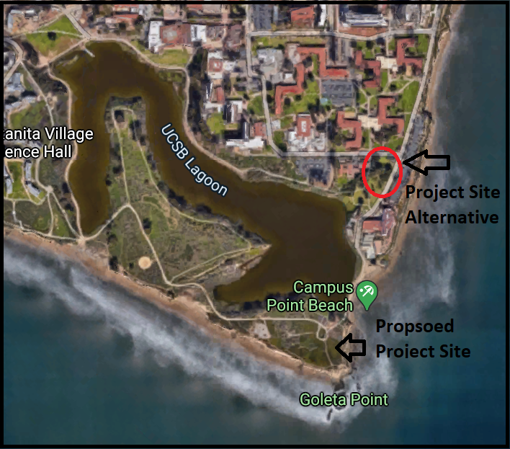

6.7 Environmentally Superior Alternative
For this project, the “No Project” alternative would reduce or avoid all project impacts. However, none of the project objectives would be achieved. CEQA Section 15126.6 requires that “If the environmentally superior alternative is the “no project” alternative, the EIR shall also identify an environmentally superior alternative among the other alternatives.” For this project, that would mean that the Off-Site Project Alternative would be the superior alternative, as it achieved all the project objectives reduced a majority of the impacts. See table 6-1 for Project Alternative Impact comparisons.

Table 6-1: Comparison of Project Alternative Impacts
Impact | Proposed Project | No Project Alt. | Reduced/  Reconfigured Project eAlt. | Offsite Alt.
BIO-1: loss of special status trees | Class II | None (-) | Class II (-) | Class II (=)
BIO-2: conflict with local conservation efforts | Class II | None (-) | Class II (=) | Class ILL (-)
BIO-3: impacts to sensitive species associated with construction | Class I | None (-) | Class II (-) | Class II (-)
Bio-4: water degradation associated with operational use | Class II | None (-) | Class II (-) | Class II (-)
Bio-5: alteration of environmentally sensitive habitat | Class I | None (-) | Class II (-) | Class II (-)
Note: Impacts with (=) would be equal to project.
Impacts with (-) would be less than project.
Impacts with (+) would be greater than project.

PUBLIC COMMENTS

Subject: Draft EIR for The Goleta Point Faculty Housing Project

Dear Ms. Katy Carter,

The Environmental Defense Center (the EDC) has reviewed the Draft Environmental Impact Report (DEIR) for the above referenced project. The EDC has reviewed the DEIR and provides the following comments:

- Section 3 Environmental Setting does not adequately describe biological resources present at the Project site. The DEIR only lists species and does not substantially describe the flora and fauna. The DEIR must provide more qualitative and quantitative detail regarding biological resources.
- Section 3 Environmental Setting should also address animals. Are there any animals present at the Project site? Even if there are none or not a substantial amount, it would be beneficial to address animal populations.
- Section 4 Impacts: Impact BIO-3 states that construction would adversely affect sensitive species in the vicinity. The DEIR should specify what species would be affected.
- Impact analysis does not conclude whether impacts associated with the construction or operational use of the Project are significant or not. In order to accurately reflect the potential for adverse impacts, the DEIR should state the degree of significance for each impact.
- The DEIR fails to acknowledge how CCBER restoration efforts would be affected by the long-term operational use of the Project. This must be clarified because it is reasonable to assume that restoration projects would experience long-term impacts.
- The DEIR must specify who would be conducting mitigation efforts, such as ecological restoration and native vegetation planting.

Thank you for the opportunity to provide comments. These comments represent our preliminary comments of the project based on the DEIR. If you have any questions regarding these comments, please contact our office.

Sincerely,

KD Casantusan
Environmental Defense Center

RESPONSE TO PUBLIC COMMENTS

Response to Public Comments
This section will address concerns brought up by KD Cabanatuan, a representative of the Environmental Defense Center. The responses are listed below, corresponding to the number of the concerned voiced in the letter Ms. Cabanatuan sent.
    - The DEIR will be revised to adequately describe biological resources present in the project site to provide additional qualitative and quantitative detail regarding the species found on or adjacent to the project site, including describing flora and fauna.
    - The Environmental Setting of DEIR will be revised to address animals that may be present on the project site. Currently, the DEIR addresses animals found adjacent to the project site within the Campus Lagoon protected habitat but does not address animals found on Campus Lagoon where the project is located.
    - The DEIR will be revised to state specific species impacted by construction under Impact BIO-3.
    - The DEIR will be revised to clarify the significance of the potential impacts of the proposed project.
    - The DEIR will be revised to incorporate further analysis on how CCBER restoration efforts would be affected by long term operational use of the project.
    - The EIR provides sufficient information regarding who would be conducting mitigation measures within the mitigation and monitoring plan. Within this section, it states that “A qualified landscape architect or arborist shall prepare the landscape plan, detailing the location and specifications of types of native plants to be incorporated and the use of native seed stock on the property” This adequately states who will implement the mitigation measure. Under the mitigation and monitoring plan, the EIR also states that “A qualified Conservation list or biologist approved by the UCSB Office of Planning research shall prepare the Beneficial Ecological Restoration Project (BERP) plan.”
The DEIR will be revised to provide additional information regarding the plant and animal species found on or adjacent to the project site and state specific species being impacted in the impact and discussion. The DEIR will also clarify the level of significance of the impacts within the discussion of the impact. The impacts on CCBER restoration efforts will also be further described, as they currently address only impacts associated with the project site&#39;s construction. The EIR shall also improve the discussion of mitigation measures proposed in the EIR. These changes to the EIR will not change the impact discussion, and therefore the EIR does not need to be recirculated.

REFRENCES
4.3 Biological Study Cortona Apartments EIR. 2017, www.cityofgoleta.org/home/showpublisheddocument?id=9341.
C. The Coastal Act, qcode.us/codes/malibu-coastal/view.php?topic=land_use_plan-1-c.
California, State of. “ESHA.” ESHA | Caltrans, dot.ca.gov/programs/environmental-analysis/coastal-program/coastal-act-policy-resource-information/esha.
“Campus Point SMCA (No-Take).” California MPAS, californiampas.org/mpa-regions/south-coast-region/campus-point-smca.
City of Calexic. Trinity Cannabis Cultivation and Manufacturing Facility DRAFT EIR.
City Of Goleta. Westar Mixed-Use Village Final EIR.
City og Goleta. Ortona Apartments Project EIR. 2018, www.cityofgoleta.org/home/showpublisheddocument?id=9346.
County of Santa Barbara Environmental Thresholds and Guidelines Manual, Resource Management Department, 2021.
Endangered Species Act | Overview. www.fws.gov/endangered/laws-policies/.
“General Plan/Coastal Land Use Plan Final EIR.” General Plan/Coastal Land Use Plan Final EIR | Goleta, CA, www.cityofgoleta.org/city-hall/planning-and-environmental-review/general-plan/view-general-plan/general-plan-coastal-land-use-plan-final-eir.
“Lagoon Island & Campus Point.” CCBER, www.ccber.ucsb.edu/ecosystem/management-areas-campus-lagoon/lagoon-island-campus-point#:~:text=Much%20of%20Campus%20Point%20is,mats%20that%20cover%20the%20landscape.
“Laws Protecting Plant and Wildlife Species.” Laws Protecting Plant and Wildlife Species - Sierra Forest Legacy, www.sierraforestlegacy.org/FC_SierraNevadaWildlifeRisk/SNWR_LawsProtectingPlantWildlifeSpecies.php#:~:text=The%20Native%20Plant%20Protection%20Act,Game%20Commission%20the%20power%20to.
NRG Ellwood Battery Storage Project Final Initial Study – Mitigated Negative Declaration. City of Goleta, 2017, www.cityofgoleta.org/home/showpublisheddocument?id=14059.
“Oceanwalk.ucsb.edu.” Oceanwalk.ucsb.edu |, www.oceanwalk.ucsb.edu/.
Office of the President. EVELOPMENT OF OCEAN ROAD FACULTY AND STAFF HOUSING, SANTA BARBARA CAMPUS Executive SUmmary. 13 Nov. 2019, regents.universityofcalifornia.edu/regmeet/nov19/f16.pdf.
“Paseo Chapala Mixed-Use.” RRM, www.rrmdesign.com/project/paseo-chapala/.
Rodriguez Consulting Inc. University of California Santa Barbara, 2017, Final Initial Study and Mitigated Negative Declaration.
Sanya Kamidi. “University Takes Second Attempt at Controversial Faculty Housing Project: The Daily Nexus.” The Daily Nexus | The University of California, Santa Barbara's Independent, Student-Run Newspaper., 21 Nov. 2019, dailynexus.com/2019-11-21/university-takes-second-attempt-at-controversial-faculty-housing-project/.
Simpson, Mary. “The Root System of Oak Trees.” Home Guides | SF Gate, 17 Nov. 2020, homeguides.sfgate.com/root-system-oak-trees-48319.html.
“A Summary of the California Environmental Quality Act (CEQA).” CDFW Prod, wildlife.ca.gov/Conservation/CEQA/Purpose.
“Threatened and Endangered Species.” CDFW Prod, wildlife.ca.gov/Conservation/CESA.
UC Santa Barbara Long Range Development Plan. 2017, www.facilities.ucsb.edu/files/docs/lrdp/LRDP%20complete%20July2019rev092019.pdf.
UCSB Housing, Dining & Auxiliary Enterprises, www.housing.ucsb.edu/community/faculty-staff-other.
UCSB Office of campus planning and designing. Final Initial Study/Mitigated Declaration Classroom Building Project.
UCSB. Engineering III Building (E-III) . June 2017.
University of California Santa Barbara. Long Range Development Plan Amendment: Arnhold Tennis Center Project. Jan. 2020.
www.facilities.ucsb.edu/files/docs/lrdp/OceanRoadPatBokSmall.pdf. Https://Www.facilities.ucsb.edu/Files/Docs/Lrdp/OceanRoadPatBokSmall.pdf. Dec. 2006.

