To: Andrew Thomas, Planning, Building and Transportation Department Director
From: Katy Carter
Date: 23 May 2021
Subject: Assessment of Alameda CA as a Healthy Community and Recommendations
__________________________________________________________________________

This memo provides an assessment of the Alameda as a Healthy Community utilizing criteria established by Richard Jackson. I focus my analysis on the City’s connectivity and access to services. Following my evaluation, I provide recommendations to make Alameda a healthier and more sustainable place.
DISCUSSION:
Connectivity
Walkability and cyclability
Alameda is a very walkable and bicyclist-friendly city. The Official City of Alameda website has maps containing walking and bike routes. The Bicycle & walking Map of Alameda shows all bike lanes and routes to the ferry building terminal, BART stations, downtown areas, and island passageways. There is also a map for routes to all the schools located within the city, including bikeways, crosswalks, traffic signals, stop signs, and crossing guards.
Public Transportation.
Alameda has various public transportation options available to the public, including AC Transit, the Alameda Loop Shuttle, the Harbor Bay Business Park Shuttle, and the Alameda Landing Express (alamedaca.gov). The AC Transit bus system allows residents to easily travel to and from the east and west side of the island and Bart stations outside the city. From BART, residents can travel throughout the Bay Area. The ferry terminal located at Alameda point also takes residents to San Francisco. However, there is only one bus within Alameda Point, and it does not travel east past Webster Street (actransit.org).
Traffic Congestion.
Due to Alameda's gird organization, there are multiple roughs for people to get to and from different locations on the island. This spreads the vehicle traffic throughout the city. However, the island's limited entry and exit points create congestion near the bridges on the island. There is often the most congestion during the weekends and rush hour. 86% of Alameda residents use cars or public transportation to get to work, with 59%t of residents commuting by driving alone, 18% using public transportation, and 9% of residents carpool (alamedaca.gov).

Access to Services
Food
Alameda has various food places, ranging from the farmer's market, small markets, grocery stores, fast-food franchises, and local sit-down restaurants. Four larger grocery stores are located throughout the city, and various smaller markets are situated in residential spaces. The farmers market is open every Tuesday, and there is a fresh produce market open every day located near the downtown park street area. However, there are few to buy food east of webster street besides Safeway and fast-food franchises. Also, many people living on Bay Farm Island must drive to the Safeway as it is also not within walking distance to most residential spaces.
Medical Care
There are multiple medical care centers in Alameda, ranging from primary physicians' offices, pediatric offices, urgent care, a hospital, and specialty care offices. One of the urgent care facilities is located in Bay Farm, and the other is on the main island. There are no medical facilities that offer general family medicine on the island's west side, only specialized services.
Physical activity
Alameda has several private and public facilities where people can get physical activity. There are approximately 15 commercial facilities that offer various types of workouts (google maps). These physical activities include platies, recreational sports games, kickboxing, yoga, karate, and generic gyms. Many of the facilities have classes and sports teams for people of all different ages. There are also a lot of public spaces that allow for physical activity. The pathway along shoreline drive accommodates pedestrians and bicyclists and has public restrooms and water fountains. There are also several baseball fields, soccer fields, and basketball courts that the public can utilize.
Commercial spaces
Several Neighborhood Mixed-Use and Community Mixed Use districts are zoned within the Alameda Land Use Diagram. Neighborhood Mixed-Use Districts are “small, compact, pedestrian-oriented ‘corner store” neighborhoods. Most of these areas are located in the center of the island between webster Street and High Street, and none are located on Bay Farm or Alameda Point. Mixed-Use areas “include the pedestrian and transit-oriented mixed-use districts along Park and Webster Street ‘Main Street’ corridors and the shopping centers” (2040 General Plan). The shopping centers include South Shore, Alameda Landing, Marina Village, and Harbor Bay.
CONCLUSION AND RECOMMENDATIONS
To make Alameda a healthier, more sustainable city, we need to address two crucial issues: 1) challenges residents living on Alameda point face regarding connectivity and access services, and 2) traffic congestion.
Residents living on the island's west side have less access to public transportation, bike paths, medical centers, and neighborhood mixed-use districts. To address these issues, the city council should prioritize developing a family physicians' medical facility on this side of the island and for a Neighborhood Mixed-Use district within the Mixed-Use Area at Alameda Point. Bike paths and sidewalks should also be constructed at Alameda Point, and the city should also add more bus lines at Alameda Point.
To address the congestion within Alameda, we reduce the number of solo drivers commuting to work. To do this, the city council should implement a Free Fair AC transit program and expand the number of bus lines throughout the city. The city should work with AC transit to expand the number of busses that run throughout Alameda, including a bus that goes from Alameda Point to Park Street and a bus that goes to Fruitvale Bart station via the high street bridge. The Free Fair AC transit program would allow Alameda residents and students to register for a clipper card (AC transit's payment method) and get allocated funds dependent on their commute to school/work travel length and access to essential services.

Photos
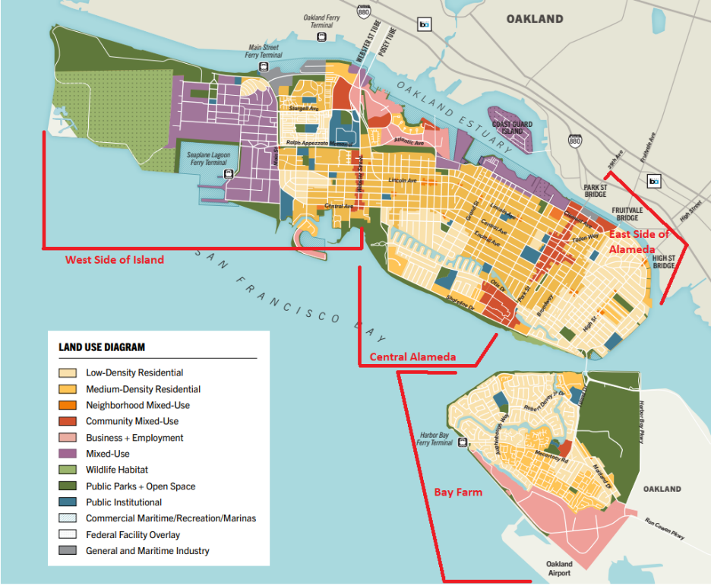
Maps
Alameda Land Use Diagram.

Image from: Alameda 2040 General Plan Draft

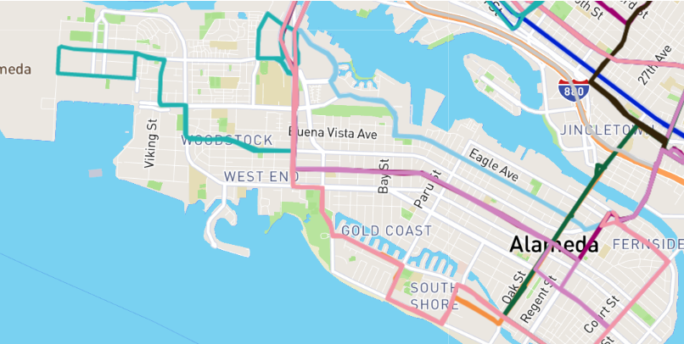
Image from: actransit.org
Map of AC transit busses in Alameda
Community Mixed-Use Areas
Park Street Alameda CA
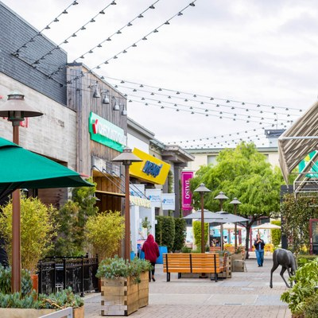
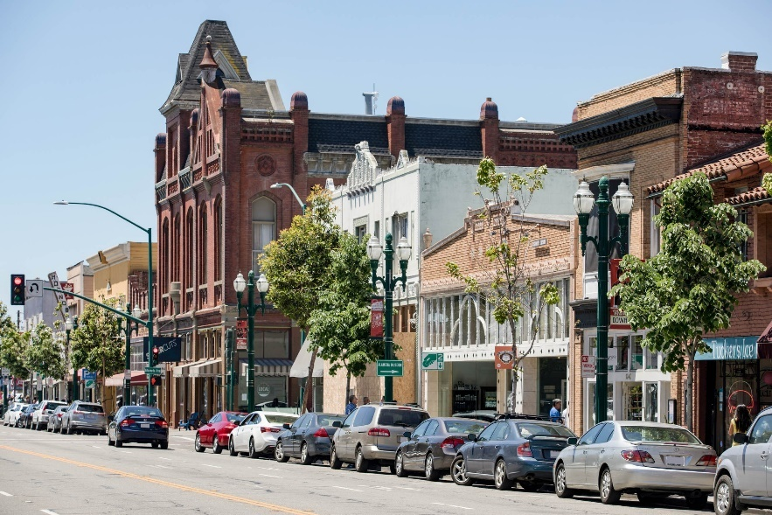
Image from: Neighborhood Guide | Trulia

South Shore Shopping Center Alameda CA

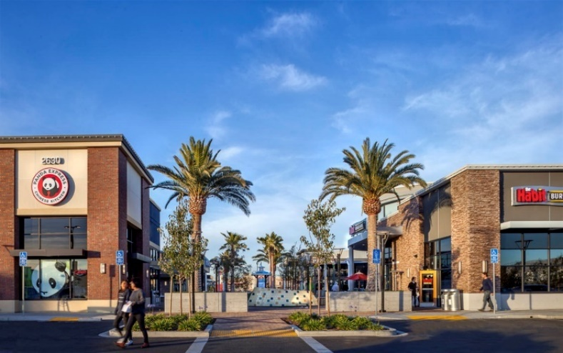
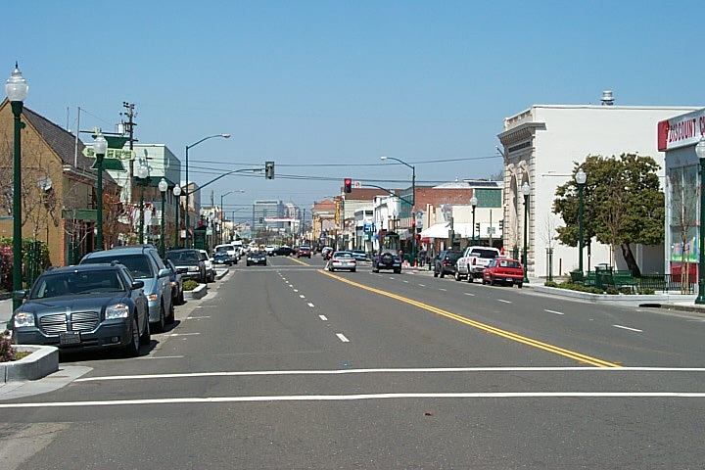
Image from: city-data.com

Webster Street Alameda CA
Alameda Landing Shopping Center Alameda CA

Image From: propertycapsule.com
Image from: Neighborhood Guide | Trulia

References
Alameda 2040 General Plan, City of Alameda, Mar. 2021. irp.cdn-website.com/f1731050/files/uploaded/AGP_MarchDraft_R2_2021.pdf.
Designing Healthy Communities, by Richard J. Jackson and Stacy Sinclair, Apha Press, 2012, pp. 159–174.
“Get Around Alameda.” Alamedaca, City of Alameda , 2021, www.alamedaca.gov/RESIDENTS/Information-for-Residents/Getting-Around-Alameda#section-2.
“Map Showing Location of Workout Facilities in Alameda CA.” Google Maps, Google, www.google.com/maps/search/work+out+facilities+alameda+CA/@37.7617502,-122.3002455,13z/data=!3m1!4b1.
“Maps & Schedules.” AC Transit, www.actransit.org/maps-schedules.
“Transportation.” Alamedaca, City of Alameda, 2021, www.alamedaca.gov/Departments/Planning-Building-and-Transportation/Transportation.

