Katy Carter
Perm number: 5598289
Term Paper

Defining and Utilizing Space

Diagrams from the three modules
In this section I will present the plan of my room from Module 1, A line drawing of my house from Module 2, and a block map of my neighborhood from Module 3.
Plan of My Room
I currently live in Isla Vista and share a room with two other people. Our room is generally organized of private space which contains each of our beds and surrounding furniture, and public space which is located in the center of the room.
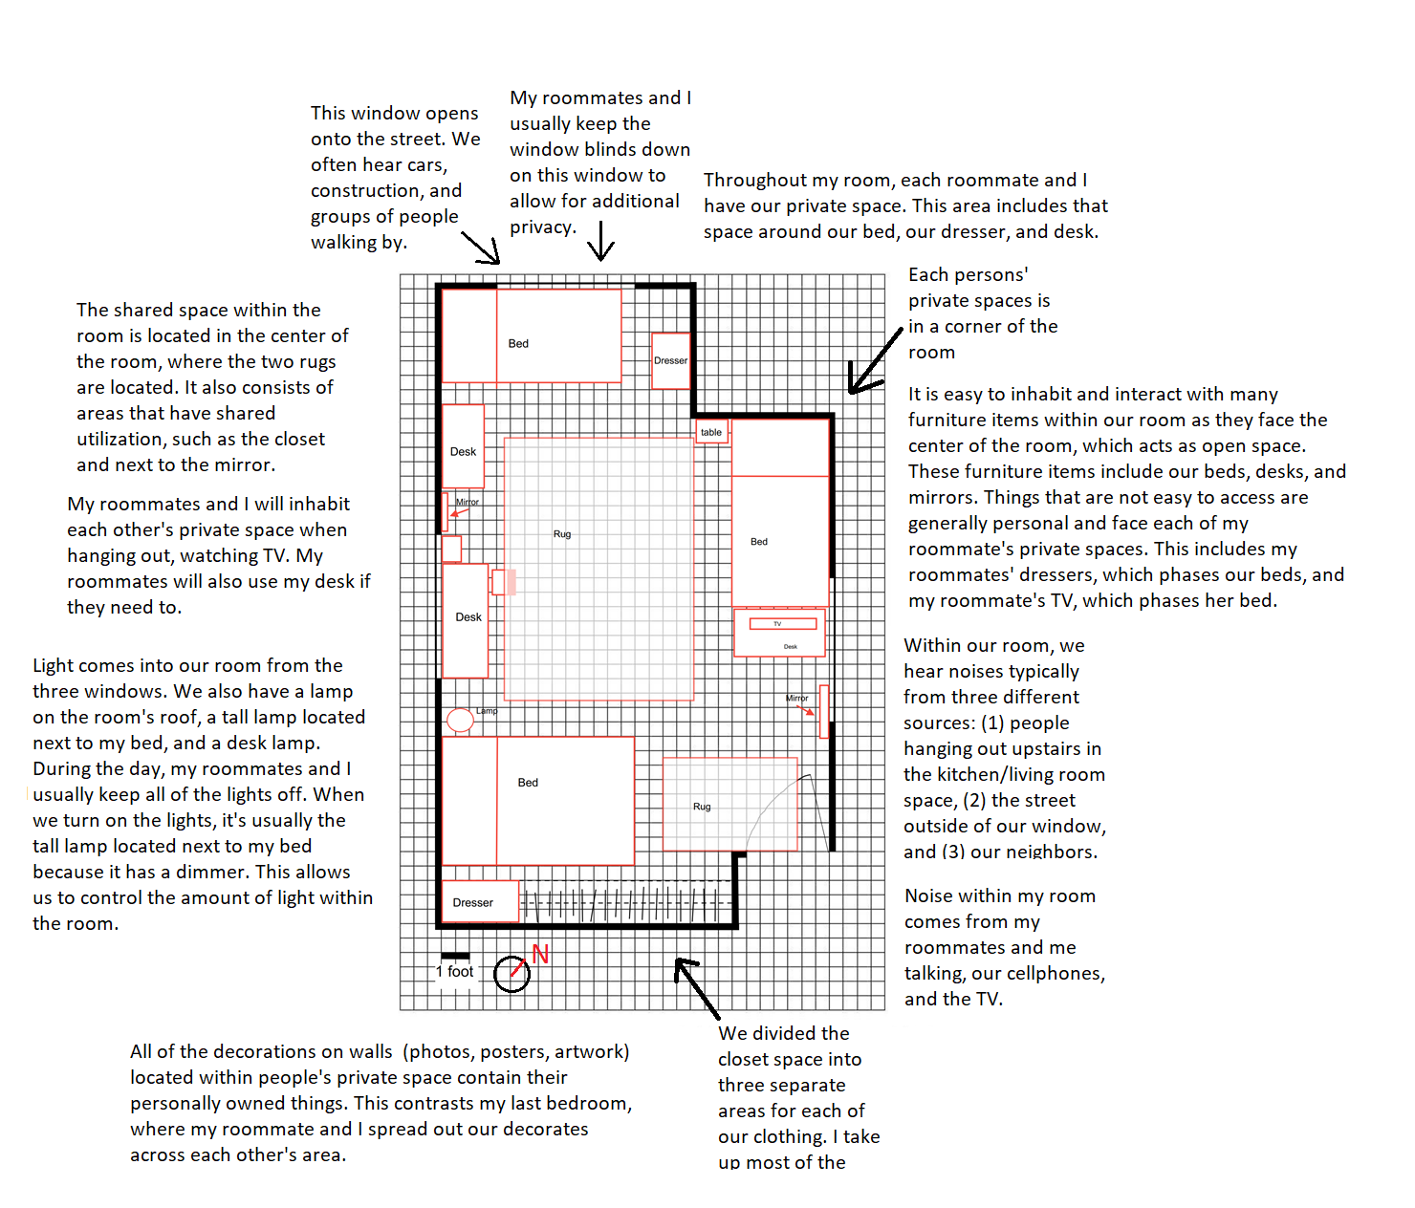

Line Drawings of my House
This diagram has two line drawings of my house, one a quiet day and the other on a busy day. Both drawings show people’s movement patterns, point of access and annotations.

Quiet Day Line Drawing:
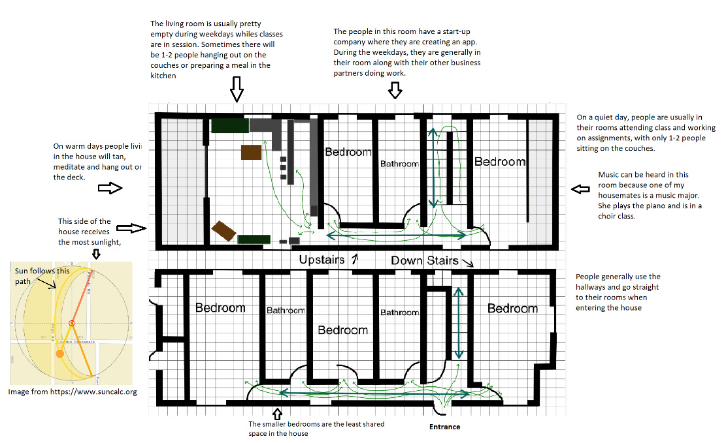
Busy Day Line Drawing:
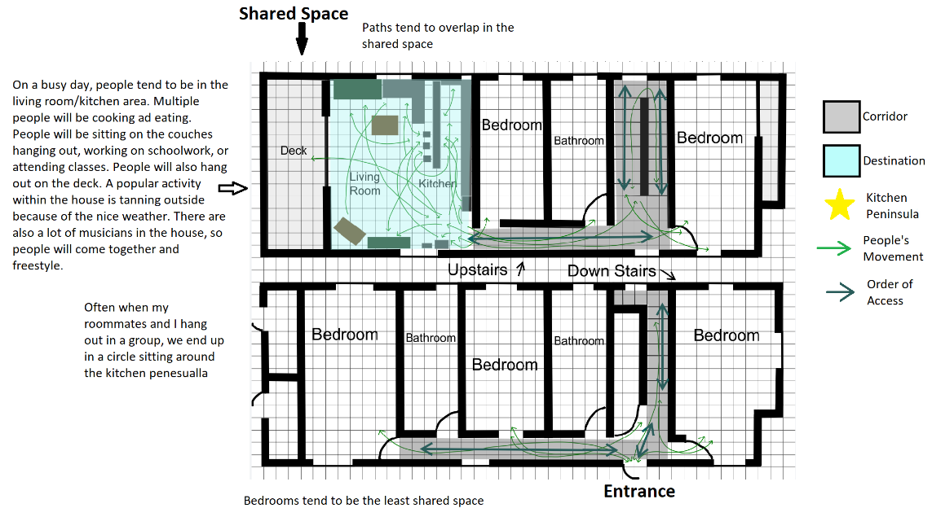
Map of my Neighborhood
For this module I took observations at a dog park and a public sitting area located in Isla Vista. I also made observations throughout my walk to and from these locations and included general observations I have about my neighborhood.

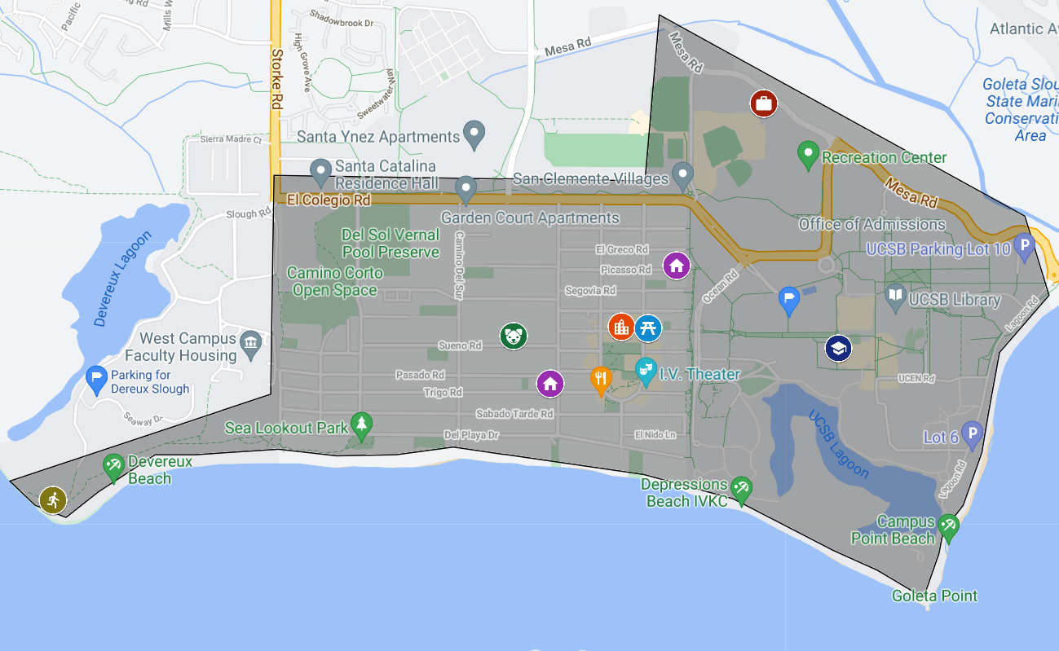
Outline of my neighborhood showing important locations:

Link to Google Map:
https://www.google.com/maps/d/u/0/edit?mid=1z705-45uHRyYXwve_D8upQjoOV6a1a6j&usp=sharing
How to read the map:
- Layers 1.0 to 1.3 all refer to observations relating to my neighborhood.
  - All my observations are in red
- Layers 2.0 to 2.2.1 relate to the site-specific locations I took observations
  - When looking at the observations, start from the top observation and work your way down. The observations follow the path I went on during my walk
- Layer 2.0 shows where on the map I sat down and conducted my observations
- Layers 2.1 and 2.1.1 relate to my first designation which was the dog park
- Layers 2.2 and 2.2.1 related to my second location which was a seating area near Starbucks

Photographs form my room, living room, and neighborhood
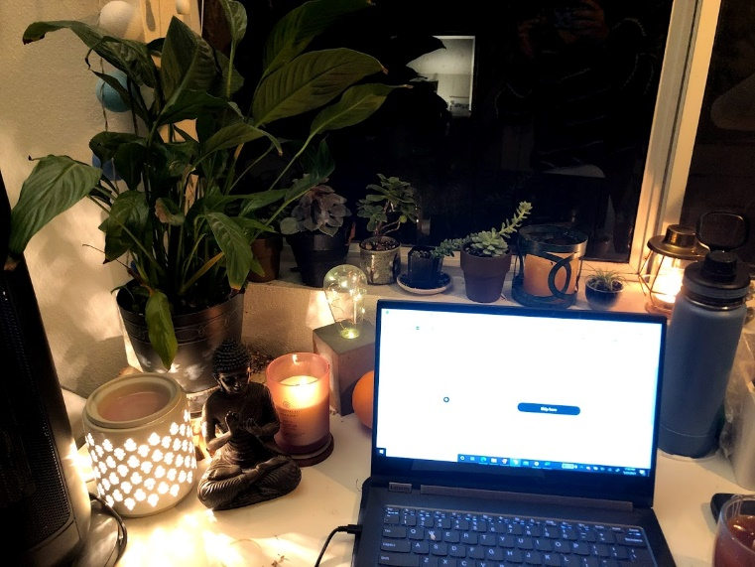
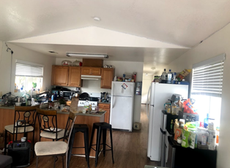
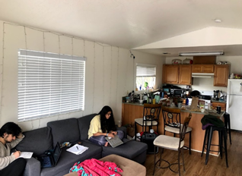
Desk in my room 1
My private space
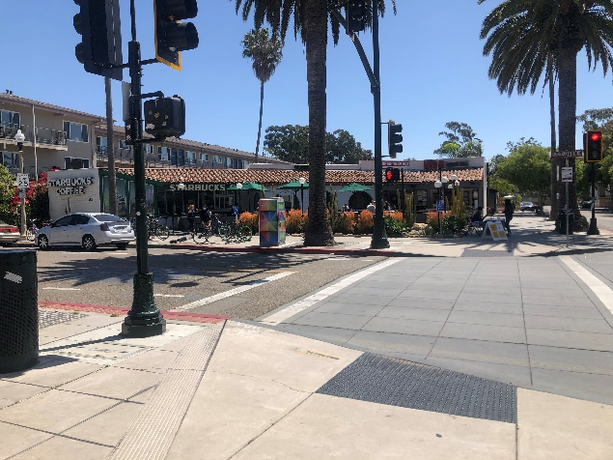
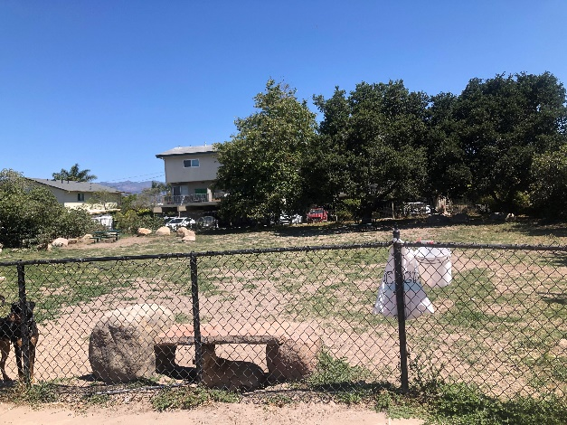
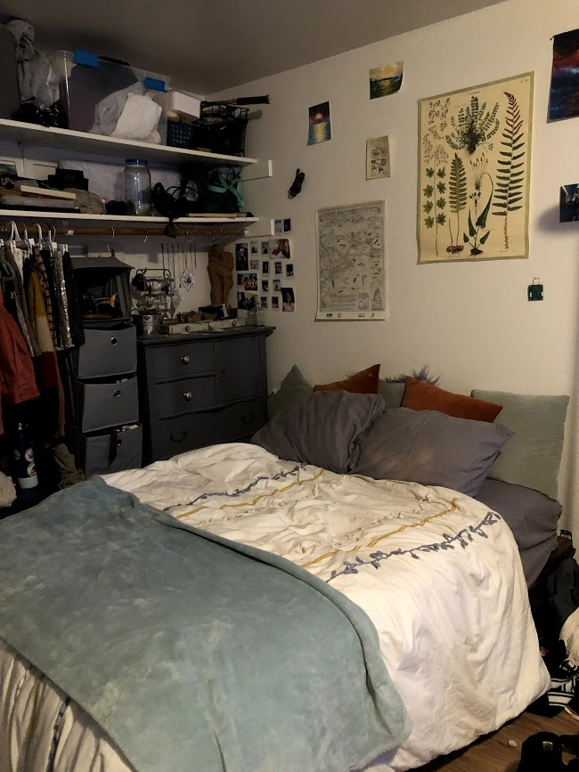
Kitchen Area
living room on a quiet day
Dhdh
Seating Area Downtown
Dog Park
I first began this project by studying my room. I measured each wall of my room and was reminded of how big it is. I live in a triple, but there is a lot of open floor space. It made me reminisce about when I first moved into the room last summer. It felt empty then. Now it is filled with beds, artwork, desks, mirrors, and rugs. While measuring my room and drawing layer one, I noticed the things on the ceiling. A heating vent is located on the sealing next to my bed. We never turn on our house heating because the upstairs part of the house turns into a sauna. I also noticed the fire alarm by the door and the ceiling light located in the center of the room. We hardly ever turn this light on. Instead, we primarily use the tall lamp that I brought with me that has a dimmer or the hanging geometric lamp hanging next to my desk that gives a warm glow.
I also noticed how my roommates and I organized our room into public and private spaces. The public space consists of the two rugs located in the center of the room. Then each of us has our own private space that contains our bed, dresser, and desk. All of our private spaces are located in the corner of the room. Things that are for our personal use generally are harder to access and phase our private spaces. As shown in the pictures, my desk faces my bed, and so do my roommates. Then our other roommate has a TV that faces her bed.
I have always known that I have too many belongings for a college student who moves to new houses each year. This was evident when moving out of my last house and into my new one. Drawing each of my belongings that were in my room truly made me realize how much unnecessary stuff I own. I have my bed with way too many pillows, a wooden dresser, a desk, one tapestry, two large posters, one framed photograph, one canvas stating life doesn't have to be perfect to be meaningful, 22 photos hanging on my wall, two rugs, a giant golden framed mirror, three wooden sculptures, a wooden box, a chair, a makeup station, six plants that are alive and two that are dead. My stuff takes up the majority of the room.
It makes sense that I have the most things in the room. I spend the most time here. One of my roommates works every day, and the other is at their girlfriend's house most of the time. For the majority of the year, our room has become the place I sleep, do homework, and where I grieved the loss of my birth father. It has become a place of comfort. It is where I can be alone but also a place where we gather, watch a movie, or just hang out. It is a place where melding styles come together through artwork on the wall, clothes hung next to each other in the closet, and sounds that fill the room. It is a room divided into three, distinguished by each person's corner, woven together by the rugs and through our movements which breach these borders. We come together then go our separate ways.
My room is the first room seen when entering the house. Next to my room is a stairwell and a horizontal hallway that leads to various rooms. The downstairs space is comprised of private space, with three bedrooms, two bathrooms, and a closet that the stairway wraps around. The stairway leads to a second hallway on the upstairs floor, with two bedrooms and a bathroom connected to it. The upstairs hallway leads to the public space of the house, which has an open floor plan with the kitchen opening into the living room.
The hallway acts as a corridor that serves as the circulation space. The organization of the house divides the space into routes and destinations. All the private spaces have single entry point doors connected to a hallway. The public space is the only room that does not have a door and is located at the end of the hallway. Through my observational study of the activities at my house, it became apparent that the house's layout impacts the relations and dynamics within the home.
The most apparent observation I made throughout the study was how people living in the house don't utilize the living room as a workplace. I began my observation on Wednesday around 3:00. The house was quiet that day. Ten people live in my house, but most of them were in their rooms doing school assignments or at work. Three of my housemates have full-time jobs, so they were gone for the whole day. For most of the time, I was the only one in the living room. Two of my housemates did come out and work on class assignments because their roommate was asleep. But people mostly came out to get food or water and return to their room.
When I first moved into the house, I found it odd that most of my housemates spent most of their time in their rooms. I believe much of the reason for this is the house's layout, which places the shared space in the back of the house (relative to the entrance door). At my last house, the entrance opened into the living room where most of my old housemates would be hanging out. You would walk in the door and be greeted by people, but you walk into an empty hallway at this house.
Saturday night was a completely different scene; most of my housemates were hanging out in the living room. Four people were cooking dinner, including myself. Three people were sitting at the kitchen peninsula, and two people were sitting on the couches. After everyone finished cooking, we all gathered in a circle around the kitchen peninsula, talked, hung out, and listened to music.
Most of my housemates and I spend time doing our work in our rooms. We usually come together in the shared space when cooking dinner or having a planned group activity. While the hallway acts as a route to the shared space, its location in the back of the house separates it from the rest of the house and acts as a barrier.
When walking around my neighborhood, I had many of the same observations similar to those inside my house. I currently live in Isla Vista. When thinking about what makes up my neighborhood, I immediately knew that I wanted to incorporate Isla Vista and the UCSB campus because of the interconnectedness of the areas. Laura McLauchlan writes in Urchins in the Infrastructure that "we shape, and are shaped by, built environment" (p.352). Both the Isla Vista Area and UCSB campus are shaped by the surrounding environment and simultaneously shape it. The same could be valid for the relationship between Isla Vista and UCSB. The students in Isla Vista shape the University, and the Campus shapes the Isla Vista community as it is many of the same people who make up both places.
For this assignment, I choose 2 locations to conduct my observations. The first location I went to be a dog park. I often dog sit my friends' dog, Jasmine, while he is at work and go there often. The second location I picked was a seating area located in the Downtown area of Isla Vista. Both sites are shared public spaces, but one is located in a residential zone and the other in retail, commercial zone.
One thing that is apparent walking around the residential zone of Isla Vista is how densely populated the area is. Much of this is because of how this unincorporated community grew alongside UCSB. In 1944 The Santa Barbara State College transitioned into a University, becoming the Santa Barbara College of the University of California. The college remained in downtown Santa Barbara until 1954 where it moved to Isla Vista and became the University of California, Santa Barbara. The regents of the University of California bought the land where the Campus currently is from the U.S Marine Air Base after WWll in 1948 (Henderson). When the Campus moves to its current location, Isla Vista was very underdeveloped. You can see this in the Ariel View of Isla Vista from 1956, where the dirt roads outline the various 65, 66, 67, and 68 blocks of Isla vista (UCSB library Spotlight).
In 1953 the first zoning of Isla vista was approved, including commercial, two-unit residential, and multiple-unit residential zones. Then in 1966, a committee was formed to create zoning regulations. This committee was comprised of Carl Chandler, an Isla Vista property manager; Dan Grant, the Isla Vista County Supervisor; Jack Schwartz an, Isla Vista Property manager; Hohn Harlan, an Isla vista realtor; and Joseph Sexton, the planning commissioners. The committee proposed larger lot sizes, a decrease in yard space, decreased in parking spaces. The loosened regulations and increase in UCSB students encourage apartment buildings and other high-density properties (Henderson). This is shown in the ariel photo taken in 1971.
Another thing that stood out to me as I am conducting my observations is the number of parks in Isla Vista. On both of my walks to different locations, I crossed three parks. If I were to walk the same distance back in Alameda, CA, I do not think I would have come across a single park. Many of the parks around IV serve as event spaces.
This past year there have been quite a lot of pop-up thrift stores at Estero Park. The open flat space and popularity of the park make it ideal for trying to sell things. Every year there is an earth day celebration in Anisq Oyo Park. I could not go to the one this year, so I am not sure what it was like during the pandemic, but in the past, there have been informational booths set up and bands performing. Little Acorn Park is a popular park for Campus organizations to have meetings at.
During My walk, I saw about a few people sitting down at the benches at Little Acorn Park, which is placed near Bagel café, a popular breakfast spot. There was also one group of people sitting down on the ground. The park's edges are defined by paths, a fence, and planting. Some trees border the park, providing some shade.
Part of the reason Isla Vista has so many parks is because of the creation of the Isla Vista Recreation and Park District in 1972. The Recreation and Park District was created shortly after the Santa Barbara Oil Spill to reflect the community's commitment to the environment. Prior to the creation of the district, there was only one park in Isla Vista. Today we have parks all along with DP and throughout IV (UC Santa Barbara Library).
Much of how the space within Isla Vista is used has remained the same since the creation of the first land zoning map. This is partly because the Isla Vista Zoning and Land Use have not changed drastically since its creation. However, Santa Barbara County has proposed new Sone summaries that are pending approval from the Coastal Commission. These new Zoning and Land Use designation maps incorporated community mix-use zones and residential mixed-use zones (County of Santa Barbara). As the physical space and intended use of Spaces in Isla Vista change, how people interact within the built environment will also.
Some of the most apparent patterns I saw while analyzing my room, house, and the neighborhood was how we direct people to public space and have private space in the background. This is shown in my room, where each of my roommates' private spaces is located in the corner of the room. The center of the room consists of the public space we all use. Within my house, there is only one room that does not have a door to it, and that is our living/kitchen room space. We have a corridor that leads people to this. Then when looking on a larger scale of my neighborhood, I saw this pattern in the placement of parks and the downtown area. Isla vista's commercial area is located in the center of my neighborhood.
Another pattern I noticed was how barriers were used to separate types and uses of space. Within my room, the edges of our furniture and rugs defined our individual spaces. The end of my bed and desk defines my space. Within our house, a kitchen peninsula is used to differentiate the living room space and kitchen. Then looking within my neighborhood, I saw this multiple times. The most noticeable one was at my second observation location, where there was a fence separating the seating area from the sidewalk. Within the seating area, people are sitting down, hanging out, and getting food. On the sidewalk side, peoples are walking to and from different locations.
The ways in which people utilize and define public and private spaces can be seen at a variety of scales. It is seen in the layout of the room design of my house. It can be seen in downtown Isla Vista which is the separate sitting area from the sidewalk. It can also be seen in the zoning of Isla Vista, with residential zones acting as private spaces and park and commercial spaces acting as public spaces. We shape the uses and barriers of these areas but are shaped in how we inhabit them.

